Student Enrollment & Course Management System
(SECMS)

STUDENT NAME: J. KEERTHIKASRI (Leader)
YEAR: III
COLLEGE CODE:304
COLLEGE NAME: ARIGNAR ANNA GOVT.ARTS COLLEGE FOR WOMEN, WALAJAPET.
DEPARTMENT: COMPUTER SCIENCE
SEMESTER: V
U. DHANUSUPRIYA
P. LEELA
C.KEERTHANA
R. VIJAYALAKSHMI

User Story:

The Student Enrollment & Course Management System (SECMS) is a Salesforce-based application designed to simplify and automate the complete student enrollment and course management process of an educational institution.As a Student, I want to view available courses, select suitable courses, submit enrollment requests, and track my enrollment status so that I can complete my registration easily. As an Enrollment Officer, I want to create and manage student records, process enrollment requests, verify student information, and monitor enrollment status so that student registrations can be handled efficiently.As an Instructor, I want to view the courses and students assigned to me so that I can manage my academic responsibilities effectively.As an Administrator, I want to manage students, courses, instructors, enrollments, approvals, and reports so that the institution can monitor academic operations from a centralized system.The system uses Salesforce Objects, Lightning App, Validation Rules, Flows, Approval Processes, Reports, and Dashboards to automate enrollment activities, reduce manual errors, improve data accuracy, and provide real-time visibility into student and course information.

- INTRODUCTION

  - Project Overview :
The Student Enrollment & Course Management System (SECMS) is a Salesforce-based application developed to simplify and automate the academic enrollment activities of an educational institution. The system provides a centralized platform for managing student information, course details, enrollment records, instructor assignments, approval processes, payments, reports, and dashboards.
In traditional academic institutions, student and enrollment information may be maintained using spreadsheets, separate systems, emails, and manual records. This can make it difficult to maintain accurate information and may lead to duplicate entries, delays, and approval bottlenecks. SECMS addresses these problems by bringing important academic operations into a single Salesforce environment.
The system allows administrators, enrollment officers, and instructors to perform their respective activities efficiently. Enrollment officers can manage student admissions and course registrations, while instructors can access information related to their assigned students and courses. Administrators can monitor enrollment activities, approvals, revenue, and overall system performance.

  - Purpose :

The Student Enrollment & Course Management System (SECMS) is a Salesforce-based application developed to simplify and automate the academic enrollment activities of an educational institution. The system provides a centralized platform for managing student information, course details, enrollment records, instructor assignments, approval processes, payments, reports, and dashboards. In traditional academic institutions, student and enrollment information may be maintained using spreadsheets, separate systems, emails, and manual records. This can make it difficult to maintain accurate information and may lead to duplicate entries, delays, and approval bottlenecks. SECMS addresses these problems by bringing important academic operations into a single Salesforce environment.
The system allows administrators, enrollment officers, and instructors to perform their respective activities efficiently. Enrollment officers can manage student admissions and course registrations, while instructors can access information related to their assigned students and courses. Administrators can monitor enrollment activities, approvals, revenue, and overall system performance.

- IDEATION PHASE
  - Problem Statement (Customer Problem Statement Template)

PS | I am  (Customer) | I’m trying to | But | Because | Which makes me  feel
PS-1 | Enrollment  Officer | manage student  enrollments efficiently | enrollment data is scattered | systems are manual and unintegrated | frustrated and errorprone
PS-2 | Administrator | track enrollments and revenue | reporting is delayed | data is not centralized | uncertain in  decision-ma king

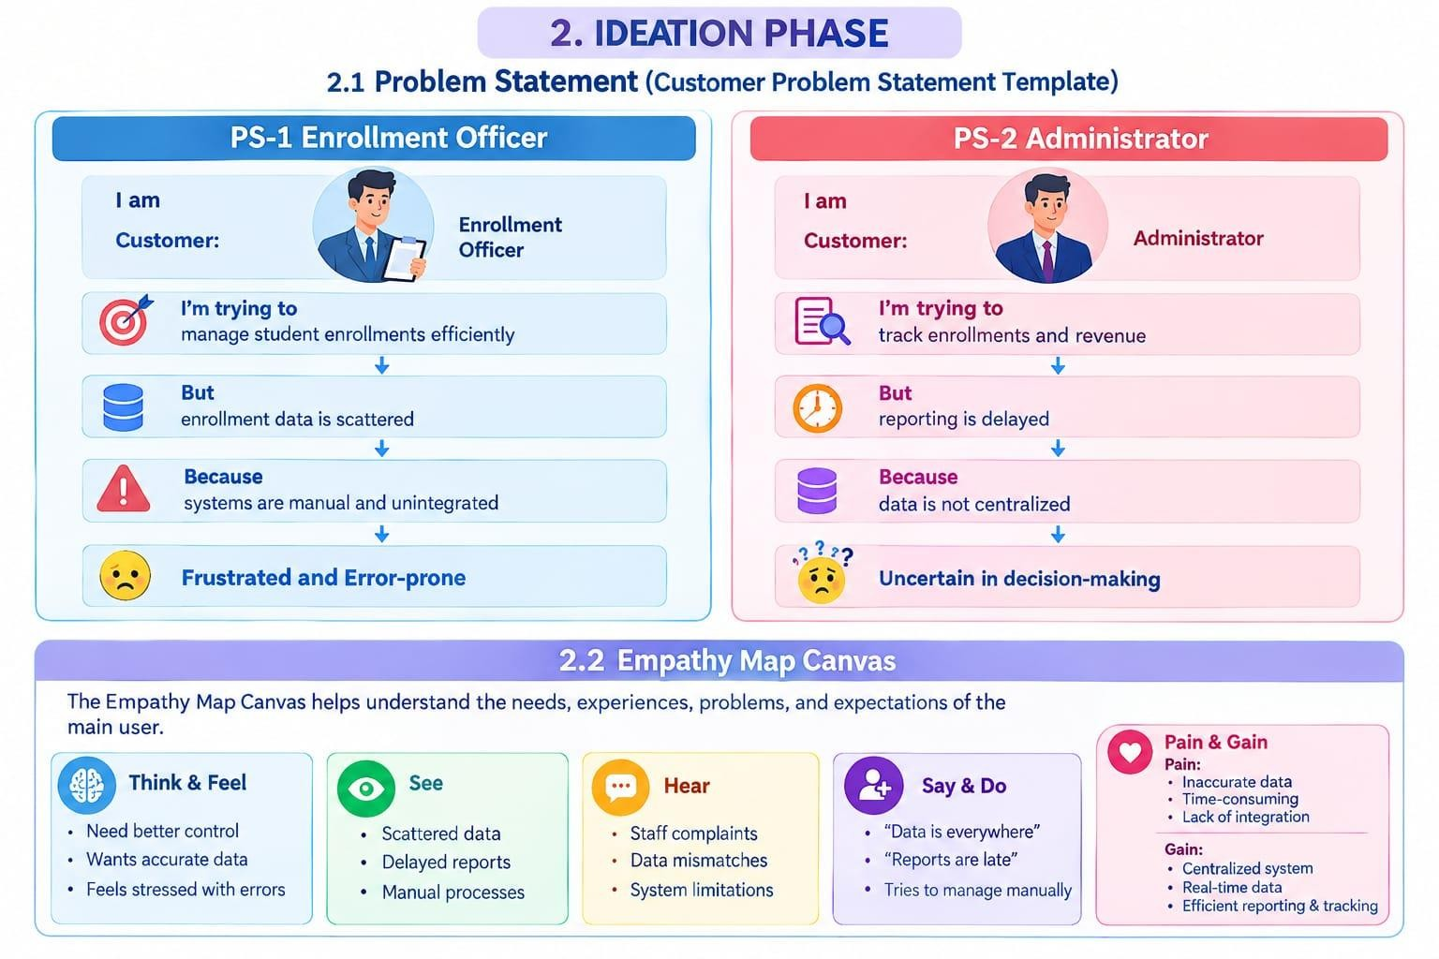

2.2 Empathy Map Canvas
The Empathy Map Canvas helps understand the needs, experiences, problems, and expectations of the main user.
User Persona: Enrollment Officer
- Think & Feel: Concerned about double bookings and revenue loss
- Hear: Complaints from students and management
- See: Multiple spreadsheets and emails
- Say & Do: Rechecks data, follows up manually
- Pain: Duplicate entries, approval bottlenecks
- Gain: Automation, dashboards, faster processing
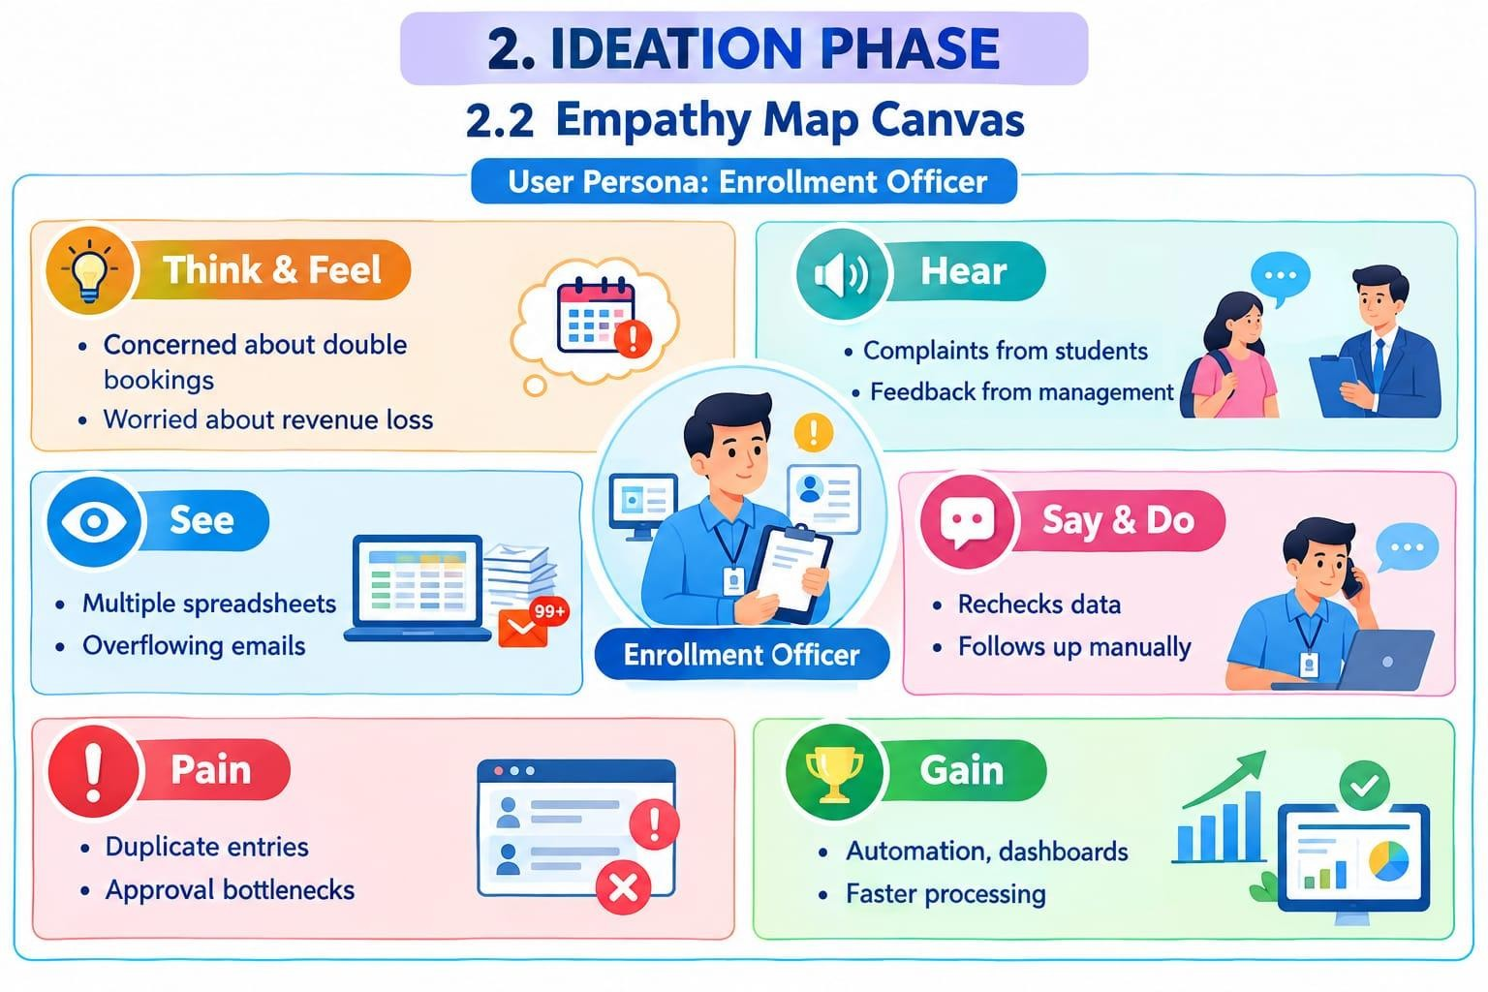
2.3 Brainstorming & Idea Prioritization:
This stage is used to generate different possible solutions and then select a suitable solution for the identified problem.
Step 1 – Brainstormed Ideas
Four possible ideas were considered:
- Spreadsheet Automation
Using automation with spreadsheets to reduce manual work.
- Standalone Enrollment Portal
Creating a separate portal specifically for managing student enrollment.
- ERP Integration
Integrating enrollment activities with an Enterprise Resource Planning system.
- Salesforce-Based Enrollment System
Using Salesforce to create a centralized and automated enrollment management system.

Student Enrollment & Course Management System (SECMS)(NM) (1).pdf
Step 2 – Grouping
The ideas were grouped into three categories:
- Manual Solutions
Solutions that depend heavily on manual data entry and management.
- Semi-Automated Solutions
Solutions that automate some activities but still require manual operations.
- Fully Automated Cloud Solutions
Cloud-based solutions that provide centralized data management and automation.

Student Enrollment & Course Management System (SECMS)(NM) (1).pdf
Step 3 – Prioritization
After comparing the proposed ideas, the project selected a Salesforce-based Student Enrollment & Course Management System (SECMS).
The document states that the Salesforce-based solution was selected based on high feasibility and high impact.
Student Enrollment & Course Management System (SECMS)(NM) (1).pdf Final Idea
Salesforce-Based Student Enrollment & Course Management System
It provides a centralized platform for managing:
Students → Courses → Enrollments → Instructors → Approvals → Payments → Reports → Dashboards

3.REQUIREMENT ANALYSIS PHASE
The Requirement Analysis Phase identifies the requirements and functionalities needed for the Student Enrollment & Course Management System (SECMS). It mainly includes the customer journey, functional requirements, non-functional requirements, and data flow.
Student Enrollment & Course Management System (SECMS)(NM) (1).pdf
3.1 Customer Journey:
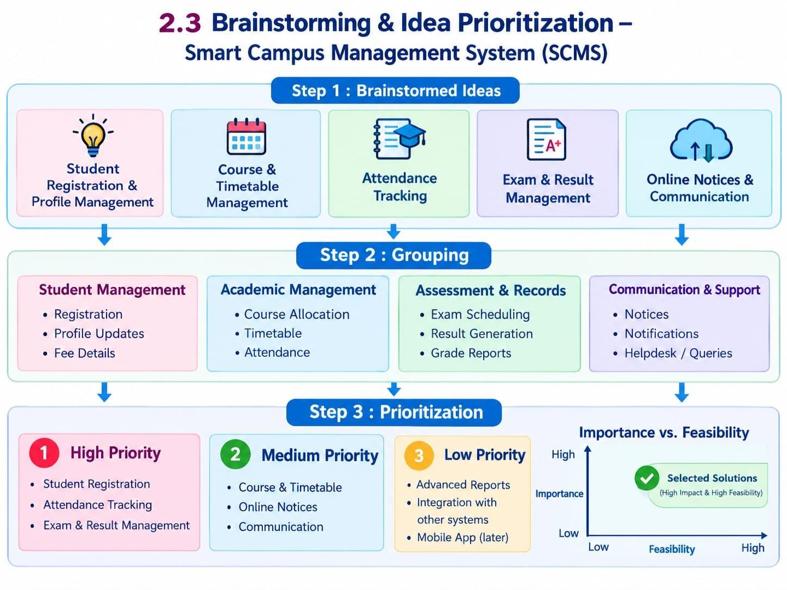
The customer journey describes the different stages involved in the student enrollment process.
Awareness & Registration
Students learn about the available courses and register in the system.
Course Selection
Students select the course they want to enroll in.
Enrollment Request
Students submit an enrollment request for the selected course.
Fee Payment
The required course fee payment process is completed.
Approval
The enrollment request is reviewed and approved or rejected by the authorized person.
Instructor Assignment
An instructor is assigned to the approved enrollment.
Reporting & Completion
Enrollment details are monitored through reports and dashboards.
Student Enrollment & Course Management System (SECMS)(NM) (1).pdf

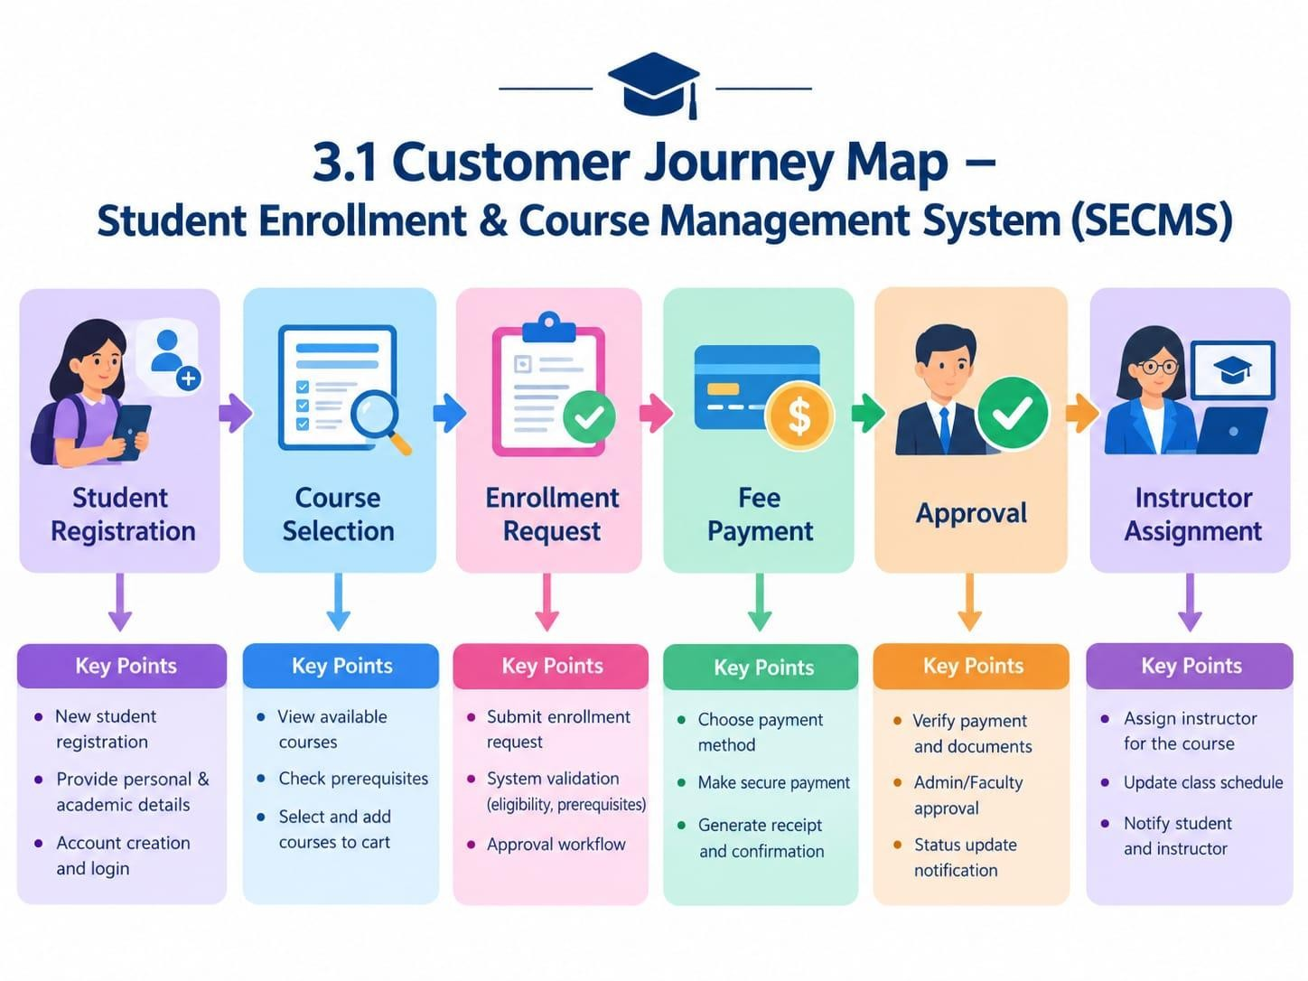

3.2 Solution Requirements
Functional Requirements

FR No | Epic | Description
FR-1 | Student Management | Manage student records
FR-2 | Course Management | Create and manage courses
FR-3 | Enrollment Processing | Request, approve, reject enrollments
FR-4 | Instructor Assignment | Auto-assign instructors
FR-5 | Reporting | Dashboards and reports

Functional requirements describe the main functions that the system must perform.
FR-1: Student Management
The system should allow users to create, store, and manage student records efficiently.
Student Enrollment & Course Management System (SECMS)(NM) (1).pdf
FR-2: Course Management
The system should allow authorized users to create and manage course information and available courses.
Student Enrollment & Course Management System (SECMS)(NM) (1).pdf
FR-3: Enrollment Processing
The system should allow users to submit enrollment requests and provide options to approve or reject those requests.
Student Enrollment & Course Management System (SECMS)(NM) (1).pdf
FR-4: Instructor Assignment
The system should automatically assign instructors to approved enrollments, reducing manual work.
Student Enrollment & Course Management System (SECMS)(NM) (1).pdf
FR-5: Reporting
The system should provide reports and dashboards to monitor enrollment information and status.

3.3 Data Flow Diagram
3.3 Non-Functional Requirements
Non-functional requirements describe the quality and performance characteristics of the system.
NFR-1: Usability
The system should be easy to use and provide a user-friendly interface.
NFR-2: Security
The system should protect student and enrollment data using role-based access.
Student Enrollment & Course Management System (SECMS)(NM) (1).pdf
NFR-3: Reliability
The system should work reliably and process data and workflows accurately.
Student Enrollment & Course Management System (SECMS)(NM) (1).pdf
NFR-4: Performance
The system should process user requests efficiently and provide information without unnecessary delays.

Student Enrollment & Course Management System (SECMS)(NM) (1).pdf
NFR-5: Scalability
The system should be able to handle an increase in students, courses, and enrollment records in the future.
Student Enrollment & Course Management System (SECMS)(NM) (1).pdf
NFR-6: Availability
The system should be available to authorized users whenever they need to access the system and its data.

Student Enrollment & Course Management System (SECMS)(NM) (1).pdf
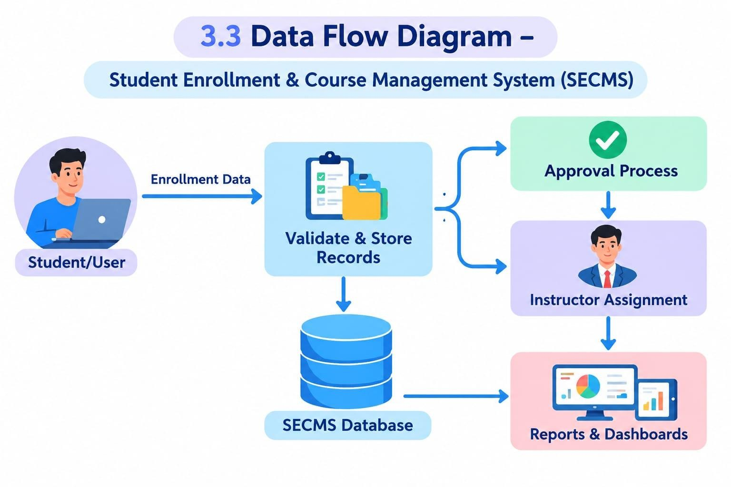

3.4 Technology Stack
Layer | Technology
UI | Salesforce Lightning
Logic | Salesforce Flows
Database | Salesforce Objects
Automation | Validation Rules, Approval Process
Reporting | Reports & Dashboards

The Data Flow Diagram (DFD) represents how data moves through the Student Enrollment System.
Student details, course information, and enrollment data are processed within the system. Salesforce Objects are used to store the data, while Salesforce Flows are used for logic and automation.
Simple meaning
Lightning = UI
Objects = Database
Flow = Automation
Validation Rule = Error checking
Approval Process = Approval workflow
Reports/Dashboard = Data analysis
- PROJECT DESIGN PHASE
The Project Design Phase defines how the
Student Enrollment & Course Management
System (SECMS) will be structured and
implemented in Salesforce. It converts the identified requirements into a practical system design.
Student Enrollment & Course Management System (SECMS)(NM) (1).pdf
4.1 Problem-Solution Fit:
The problem-solution fit explains how the proposed SECMS addresses the problems identified during the requirement analysis phase.
Student and course information is maintained in a centralized system.
Enrollment activities are organized through structured workflows.
Approval processes reduce manual work.
Instructor assignment can be automated.
Reports and dashboards provide better visibility of enrollment information.
Salesforce provides a scalable platform for implementing the solution.
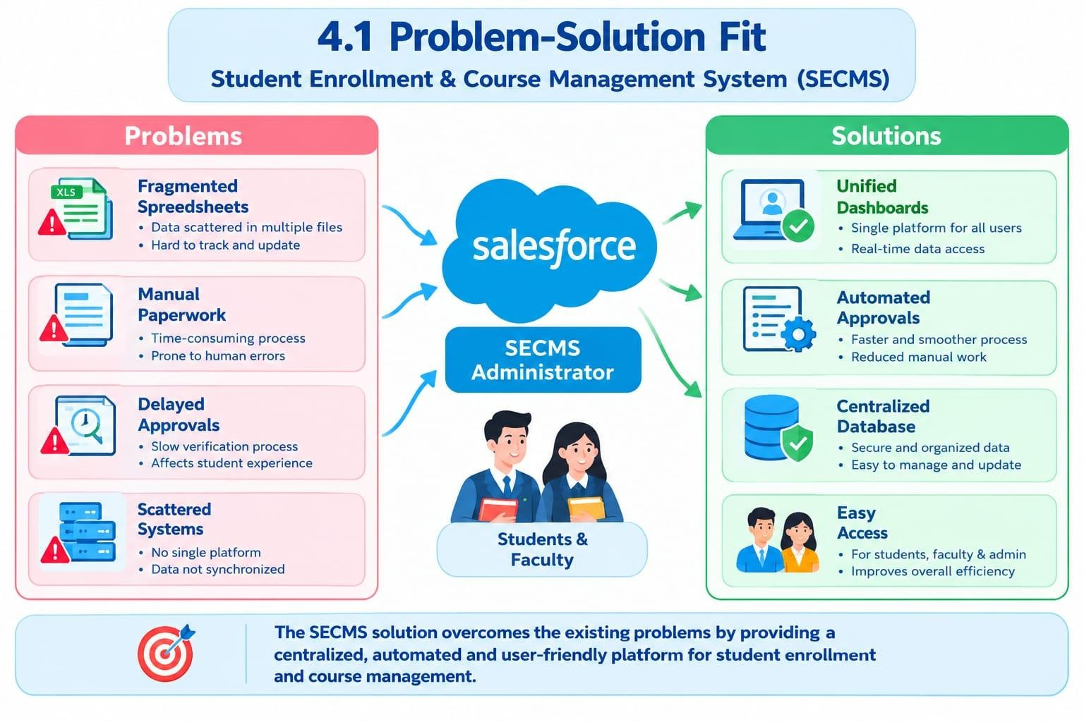

4.2 Proposed Solution
Functional Requirements

Parameter | Description
Problem | Manual enrollment handling
Solution | Salesforce-based SECMS
Novelty | End-to-end automation
Social Impact | Improved student experience
Revenue Model | Institutional deployment
Scalability | Multi-department support

The proposed solution is a Salesforce-based Student Enrollment & Course Management System.
The system manages the major academic enrollment activities in one platform, including:
Student management
Course management
Enrollment processing
Instructor assignment
Approval workflows
Reporting and dashboards
Data management and security
This helps replace fragmented and manual processes with a centralized and automated system.

4.3 Solution Architecture
The system architecture connects:
Salesforce Objects
→ Automation Flows
→ Approval Process
→ Reports
→ Dashboards
→ Security
This creates one integrated academic-management system.

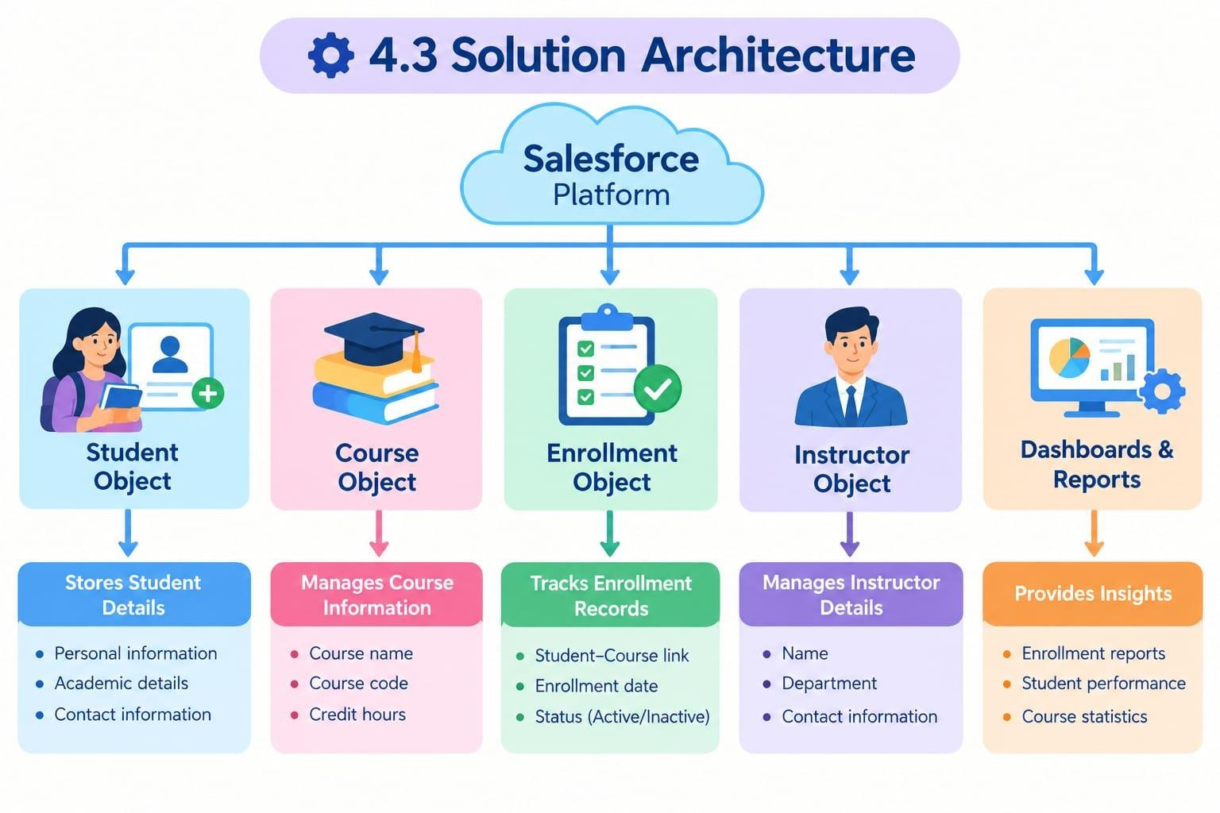
- PROJECT PLANNING & SCHEDULING
5.1 Project Planning
The project uses Agile methodology.
Agile means:
Project is developed in small stages called Sprints.
PDF mentions:
Epics
User Stories
Story Points
Sprint execution
Velocity calculation
Student Enrollment & Course Management System (SECMS)(NM) (1).pdf
Sprint | Functional  Requirement  (Epic) | User  Story  Number | User Story / Task | Story Points | Priority | Team  Member  s
Sprint-1 | Developer Setup | USN-1 | As a system administrator, I want to create a Salesforce developer account so that I can configure and deploy the Student Enrollment system.. | 1 | High | Member1
Sprint meaning
A Sprint is a fixed development period in which specific tasks are completed.
- Agile methodology
- Epics → Stories → Story Points
- Sprint-based execution
- Velocity calculation used for estimation
Product Backlog, Sprint Schedule, and Estimation (4 Marks)
USN-1
Admin wants to create Salesforce developer account.
USN-2
Admin wants custom objects for:
Student
Course
Enrollment
Instructor
USN-3
User wants separate tabs for each object.
USN-4
Sprint-1 | Data Modeling | USN-2 | As an admin, I want to create custom objects for Student, | 3 | High | Member2
Admin wants appropriate fields for student/course/enrollment data.
USN-5
Enrollment officer wants centralized Lightning application.
USN-6
Admin wants relationships between objects.
USN-7
User wants customized page layouts.
USN-8
System validates required fields and enrollment limits.
USN-9
System automates enrollment processing and notifications.
USN-10
Admin wants enrollment approval process.
USN-11
Admin wants role-based security.
USN-12
Manager wants enrollment/course/instructor reports.
USN-13
Manager wants dashboards for enrollment statistics.
Sprint | Functional  Requirement  (Epic) | User  Story  Number | User Story / Task | Story Points | Priority | Team  Member  s
 |  |  | Course, Enrollment, and Instructor so that academic data can be stored and managed efficiently.
Sprint-2 | Data Modeling | USN-3 | As a user, I want dedicated tabs for each object so that I can easily navigate between students, courses, enrollments, and instructors. | 3 | High | Member3
Sprint-2 | Data Modeling | USN-4 | As an admin, I want to create relevant fields such as student details, course information, and enrollment status so that complete records can be captured accurately. | 5 | High | Member4
Sprint-2 | Data Modeling | USN-5 | As an enrollment officer, I want a centralized Lightning App so that I can access all academic operations from one interface. | 3 | High | Member4
Sprint-2 | Data Modeling | USN-6 | As an admin, I want to define relationships between students, courses, and enrollments so that the system can logically link and track academic activities. | 5 | Medium | Member1
Sprint-2 | Data Modeling | USN-7 | As a user, I want customized page layouts so that only relevant information is displayed, improving clarity and ease of data entry. | 5 | High | Member2
Sprint-3 | Automation | USN-8 | As a system, I want to validate input data such as mandatory fields and enrollment limits so that incorrect or incomplete records are prevented. | 3 | High | Member4
Sprint-3 | Automation | USN-9 | As a system, I want automated flows to handle enrollment processing and notifications so that manual effort is reduced and processes become faster. | 3 | High | Member4
Sprint-3 | Automation | USN-10 | As an administrator, I want an approval process for enrollment requests so that registrations are verified before confirmation. | 5 | High | Member1
Sprint-4 | Security | USN-11 | As an admin, I want to configure rolebased security so that users can only access data relevant to their responsibilities. | 5 | High | Member2

Sprint-5 | Reports | USN-12 | As a manager, I want reports on student enrollments, course registrations, and instructor assignments so that I can monitor academic operations. | 4 | High | Member3
Sprint-6 | Dashboards | USN-13 | As a manager, I want visual dashboards showing enrollment | 4 | Medium | Member4

Sprint | Total Story Points | Duratio  n | Sprint Start Date | Sprint End Date  (Planned) | Story Points  Completed  (as on  Planned End  Date) | Sprint Release Date  (Actual)
Sprint-1 | 20 | 6 Days | 24 Oct 2022 | 29 Oct 2022 | 20 | 29 Oct 2022
Sprint-2 | 20 | 6 Days | 31 Oct 2022 | 05 Nov 2022
Sprint-3 | 20 | 6 Days | 07 Nov 2022 | 12 Nov 2022
Sprint-4 | 20 | 6 Days | 14 Nov 2022 | 19 Nov 2022
Sprint | Functional  Requirement  (Epic) | User  Story  Number | User Story / Task | Story Points | Priority | Team  Member  s
 |  |  | statistics and trends so that I can quickly analyze system performance.

Project Tracker, Velocity & Burndown Chart: (4 Marks)

6. Project Development Phase:
Project Flow:
Milestone 1 – Salesforce Developer Account
Create a free Salesforce Developer account and set up the Salesforce environment for developing the SECMS application.
Milestone 2 – Create Objects Create four custom objects:
Student – stores student details.
Course – stores course information.
Instructor – stores instructor details.
Enrollment – manages student course enrollment.
Milestone 3 – Create Tabs
Create custom tabs for Student, Course, Instructor, and Enrollment objects so users can easily access them from the Salesforce interface.
Milestone 4 – Create Lightning App
Create a dedicated SECMS Lightning App and add the required tabs and features for easy navigation.
Milestone 5 – Create Fields
Add necessary fields such as Student Name, Email, Phone, Course Name, Course Fee, Instructor Name, Enrollment Date, and Status.
Milestone 6 – Create Relationships
Establish relationships between objects. For example, Student → Enrollment → Course and Instructor → Course, allowing related information to be connected.
Milestone 7 – Customize Page Layouts
Arrange fields, sections, related lists, and buttons on each object's page layout to make the system user-friendly.
Milestone 8 – Create Validation Rules
Create rules to prevent incorrect data entry. For example, preventing enrollment when required information is missing or ensuring valid values are entered.
Milestone 9 – Create Flows
Use Salesforce Flow to automate processes such as updating enrollment status, sending notifications, or creating related records automatically.
Milestone 10 – Create Approval Process
Create an approval process for important actions, such as approving student enrollment requests before they are finalized.
Milestone 11 – Create Reports
Create reports to analyze system data, such as:
Students by course
Course enrollment details
Instructor-wise courses
Enrollment status
Milestone 12 – Create Dashboards
Create dashboards with charts and graphs to display important information such as total students, courses, enrollments, and enrollment status.
Milestone 13 – Configure Security
Configure Salesforce security using profiles, permission sets, roles, sharing settings, and object/field permissions to control user access.
Milestone 14 – Conclusion
The Student Enrollment & Course Management System provides a centralized Salesforce platform to manage students, courses, instructors, and enrollments. Automation, reports, dashboards, and security make the system efficient and easy to manage.

What you'll learn
- Real-time Salesforce project implementation
👉 Learn how to build and configure a real Salesforce project practically, not just theory.
Example: Create Student, Course, Instructor and Enrollment records.
- Designing custom objects and relationships
👉 Create your own objects and connect them with each other.
Example: An Enrollment is connected to a Student, Course and Instructor.
- Creating page layouts & record types
👉 Decide which fields appear on a record page and create different types of records.
Example: Enrollment can have:
New Enrollment
Re-Enrollment
- Writing validation rules
👉 Validation rules prevent users from entering incorrect data.
Example: If fees are not paid, the enrollment should not be approved.
- Building automation with flows
👉 Salesforce Flow automatically performs tasks when certain conditions happen.
Example: When enrollment is approved → automatically update the student's status.
- Creating approval workflows
👉 Sends a record to the appropriate person for approval.
Example: Enrollment Request → Training Manager → Approve/Reject.
- Developing reports & dashboards
👉 Reports show data in an organized format, while dashboards display important information visually.
Example:
Students by Status
Enrollments by Course
Pending Approvals
Revenue Report
- Setting up security with profiles, permission sets, and sharing
👉 Controls who can see, create, edit, or delete data.
Example:
Admin: Full access
Enrollment Officer: Create/update enrollments
Instructor: View assigned enrollments
- End-to-end application testing
👉 Test the complete application from beginning to end to make sure everything works correctly.
Example: Create Student → Select Course → Create Enrollment → Approval → Instructor Assignment → Report

Milestone 1-Salesforce :
Introduction:

What Is Salesforce?
Salesforce is a cloud-based platform that provides tools for storing, managing, and accessing organizational data. In the Student Enrollment System, Salesforce is used to manage student details, course information, enrollment records, and approval processes.
It provides a centralized platform for maintaining all student and course-related information.
Student details such as name, email, phone number, and enrollment status can be stored securely.
Course information such as course name, category, duration, and fees can also be managed easily.
The system helps staff create and track student enrollment records efficiently.
Salesforce automation and approval processes help reduce manual work and improve accuracy. Overall, Salesforce makes the Student Enrollment System organized, efficient, and easy to manage.

https://youtu.be/r9EX3lGde5k

Activity 1: Creating Developer Account:
Creating a developer org in salesforce.
Go to https://developer.salesforce.com/signup

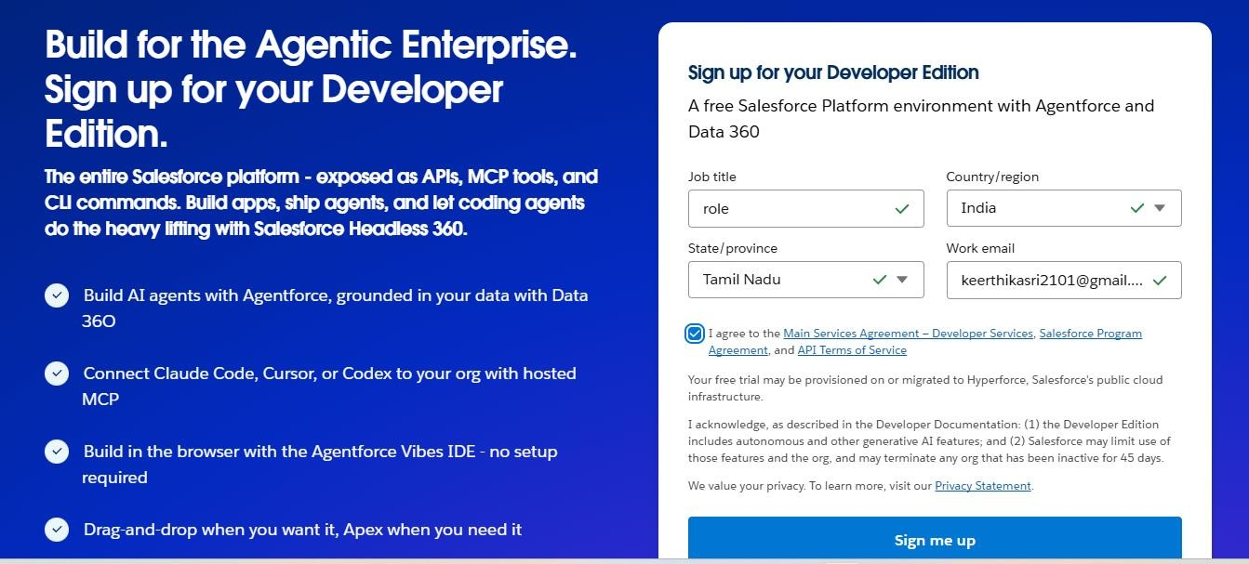

First name & Last name :
Email :
Role : Developer
Company : College Name
County : India
Postal Code : pin code
Username : should be a combination of your name and company This need not be an actual email id, you can give anything in the format :
username@organization.com
Click on sign me up after filling these.

Activity 2: Account Activation:

- Go to the inbox of the email that you used while signing up. Click on the verify account to activate your account. The email may take 5-10mins.

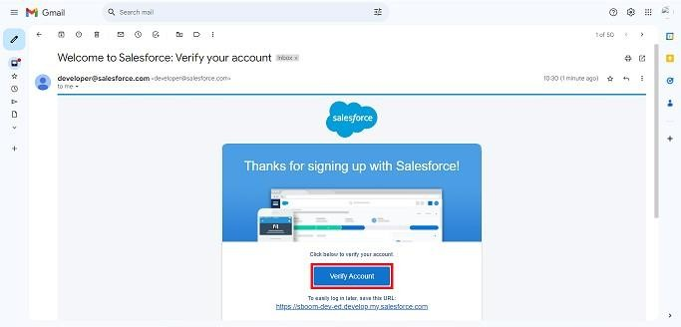

- Click on Verify Account
- Give a password and answer a security question and click on change password.

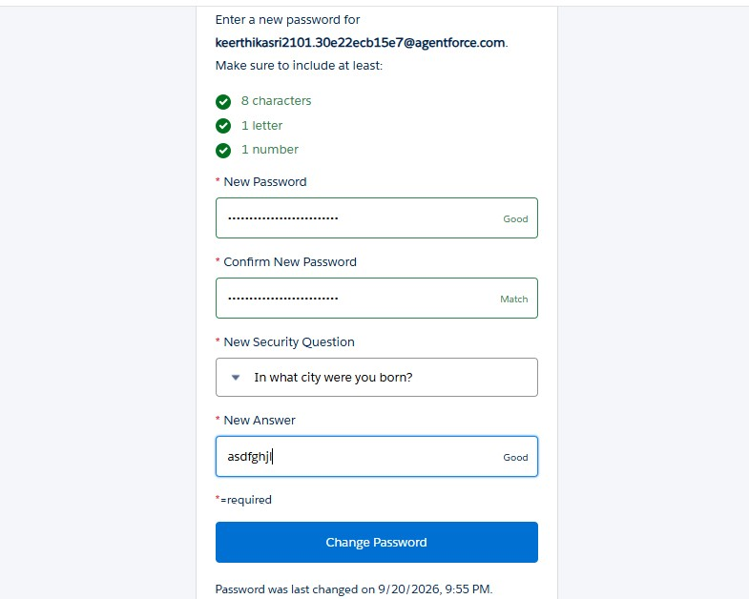
- Then you will redirect to your salesforce setup page.
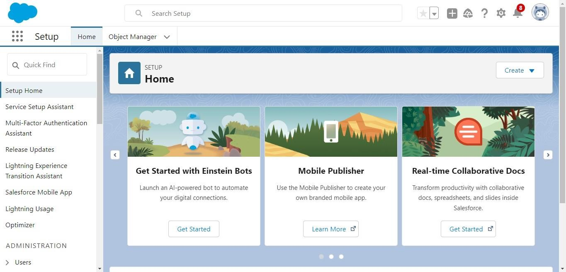

Milestone 2 – Objects:
Activity 1: Creating Student Object:
The purpose of creating the Student custom object is to store and manage information about students such as their personal details, contact information, and enrollment status.

To create the Student object:

Go to the Setup page.

Click on Object Manager.

Click on Create → Custom Object.

Enter the details as below:
  - Label: Student
  - Plural Label: Students
  - Object Name: Student
  - Record Name: Student Name
  - Data Type: Text
  - Under Optional Features, select:
  - Allow Reports
  - Allow Activities (optional but recommended) 9. Track Field History (optional, if you want)
  - Under Search Status, select:
  - Allow Search
  - Click Save.

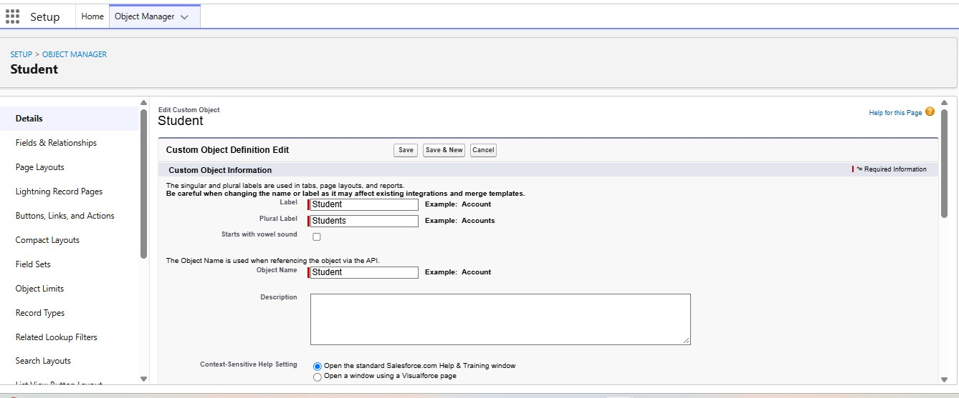

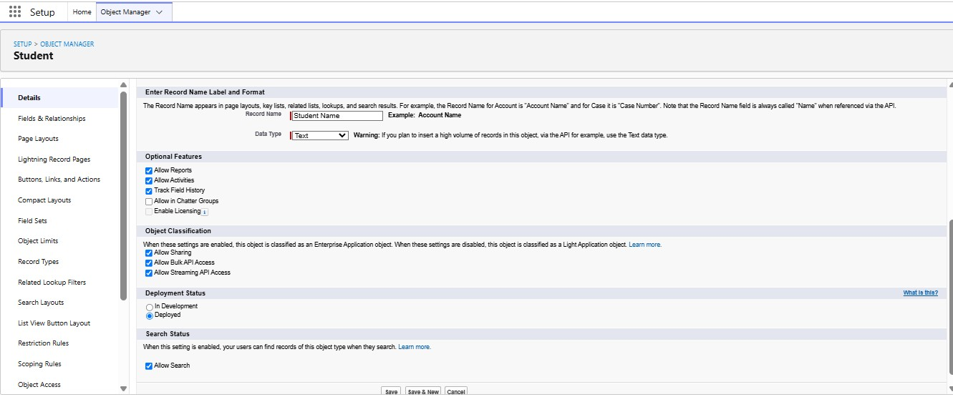

In the same way Create Courses, Instructors, and Enrolments objects

Milestone 3 - Fields:
Table 1: Student Object Fields:
Field Label |  | Data Type
Student Name |  | Text  (Standard)
Email |  | Email
Phone |  | Phone
Date of Birth |  | Date
Student Status |  | Picklist
Address |  | Text Area
Field Label | Data Type
Course  Name | Text  (Standard)
Category | Picklist
Duration | Number/Text
Course Fee | Currency
Description | Text Area

Table 2: Course Object Fields:

Table 3: Instructor Object Fields:

Field Label | Data Type
Instructor  Name | Text  (Standard)
Instructor  Code | Text
Expertise | Picklist
Phone | Phone
Email | Email

Table 4: Enrollment Object Fields:

Field Label | Data Type
Student | Lookup  (Student)
Course | Lookup (Course)
Instructor | Lookup  (Instructor)
Enrollmen t Date | Date
Enrollmen t Status | Picklist
Fees Paid | Checkbox
Total  Amount | Currency
Comment  s | Text Area

Milestone 4 – Create Relationships:
  - Activity 1: Create Lookup from Enrollment to Student:
1.
Go to Setup → click Object Manager.
  - Type Enrollment in Quick Find → click Enrollment__c object.
  - Click Fields & Relationships → click New. 4. Select Lookup Relationship → click Next.
- For Related To, select Student__c → click Next.
- Enter Field Label: Student (API Name: Student__c).
- Click Next through Field-Level Security and Layout options (ensure it’s visible and added to layout).
- Click Save.
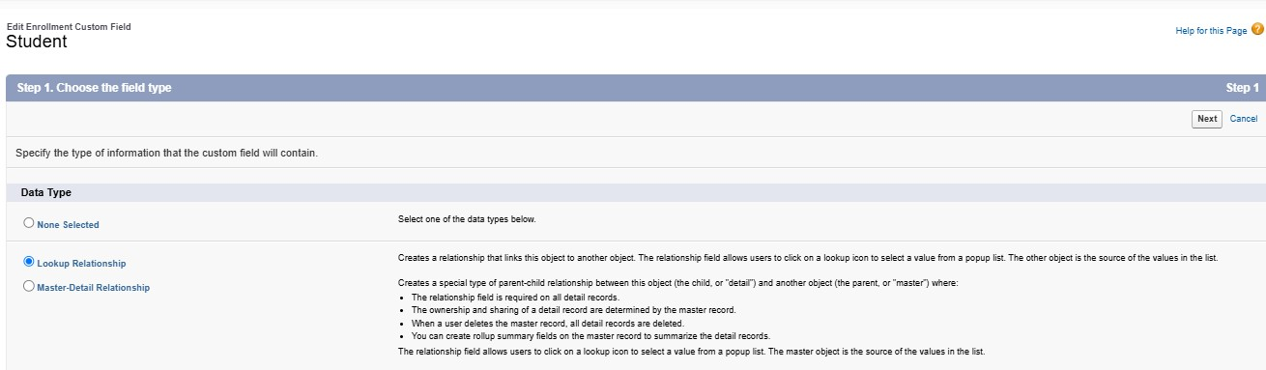

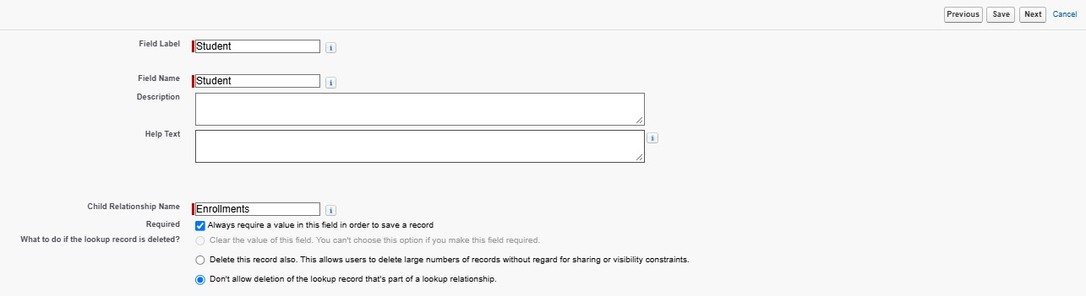

Activity 2: Create Lookup from Enrollment to Course
Purpose:
To link each Enrollment to a Course.

Steps:
- Go to Setup → Object Manager → Enrollment__c.
- Click Fields & Relationships → New.
- Select Lookup Relationship → Next.
- Related To: select Course__c → click Next.
- Field Label: Course (API Name: Course__c).
- Click Next (set visibility and layout) → Save.
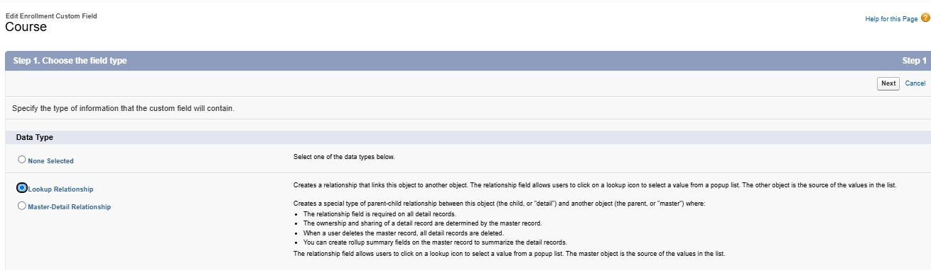

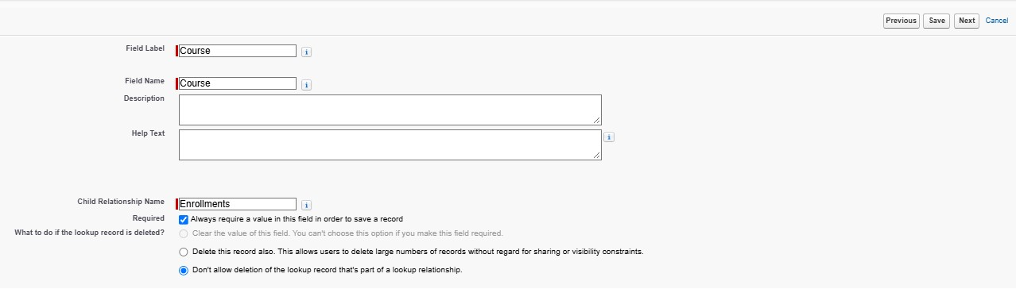

Activity 3: Create Lookup from Enrollment to Instructor:
Purpose:
To store which Instructor is assigned to a particular Enrollment.

Steps:
- Go to Setup → Object Manager → Enrollment__c.
- Click Fields & Relationships → New.
- Choose Lookup Relationship → Next.
- Related To: select Instructor__c → Next.
- Field Label: Instructor (API Name: Instructor__c).
- Complete Field-Level Security and Page Layout options → Save

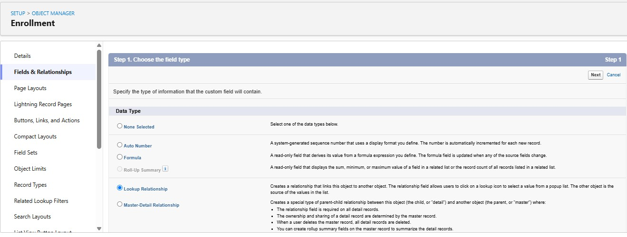

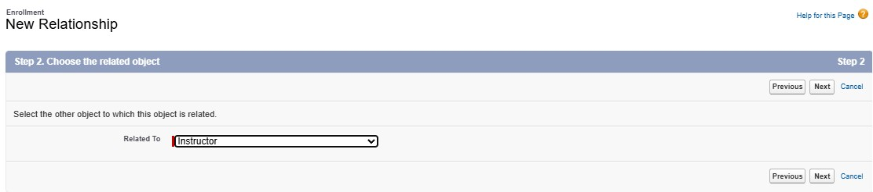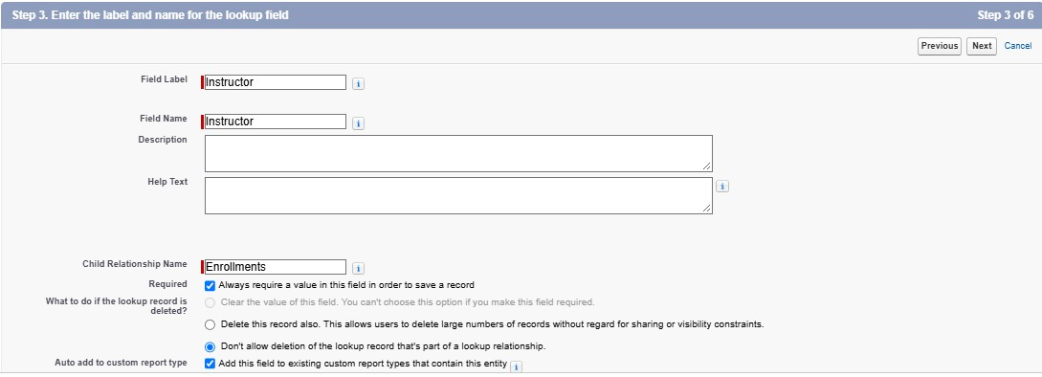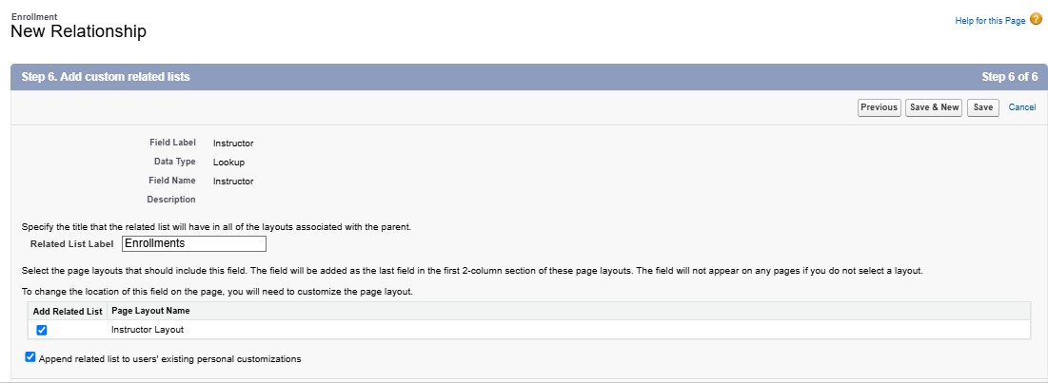

Milestone 5- Vallidation Rules:
Activity 1: Student Email Domain Validation
Purpose:
To ensure students use only allowed institutional email addresses.

Steps:

Go to Setup → Object Manager → Student__c.
Click Validation Rules → New.
Rule Name: Student_Email_Domain_Validation.
Error Condition Formula: (example for @student.edu)
● NOT(CONTAINS(Email__c, "@student.edu"))

Error Message: Email must be a valid student institutional email.
Error Location: Field → Email__c. Click Save.
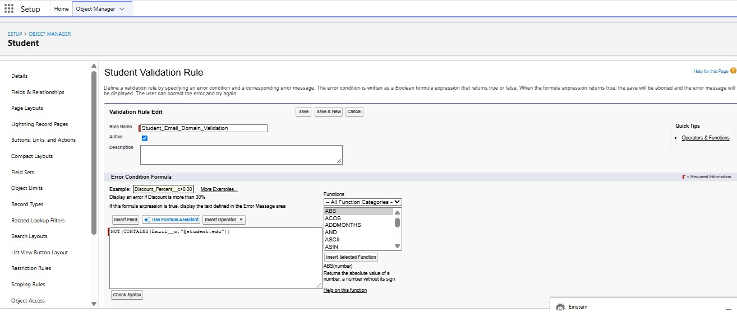

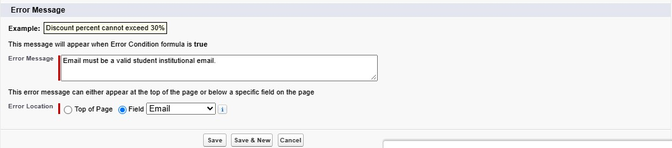

Activity 2: Fees Must Be Paid Before Approval

Purpose:
Route Enrollment requests to Training Manager for approval or rejection.

Steps:

- Go to Setup → Approval Processes → select Enrollment__c.
- Click Create New Approval Process → Use Standard Setup.
- Process Name: Approval_Enrollment_Request.
- Entry Criteria: Enrollment_Status__c = "Requested".
- Save and configure steps.
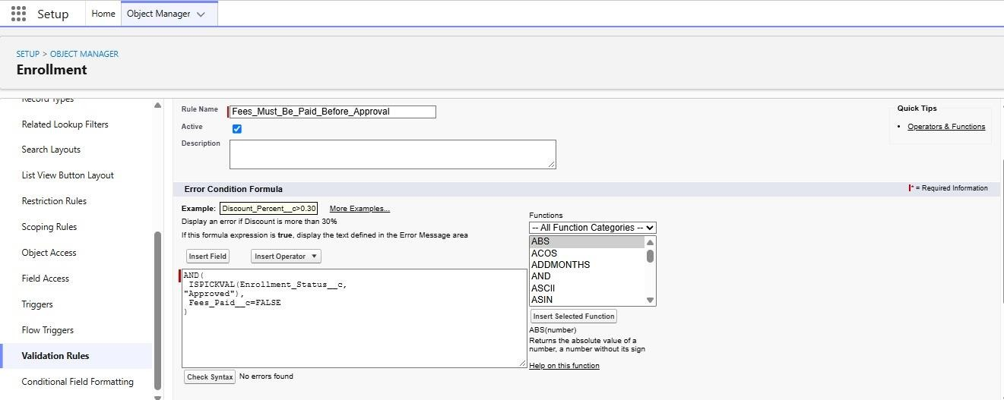

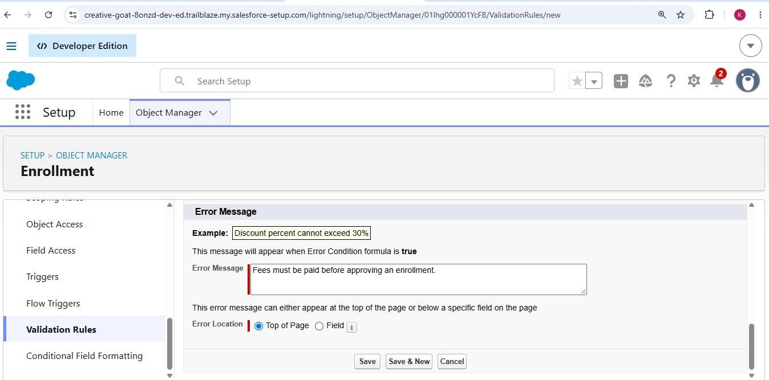

Milestone 6 – Approval Process Activity
1: Create Approval Process for Enrollment Requests Purpose:
Route Enrollment requests to Training Manager for approval or rejection.
Steps:
- Go to Setup → Approval Processes → select Enrollment__c.
- Click Create New Approval Process → Use Standard Setup.
- Process Name: Approval_Enrollment_Request.
- Entry Criteria: Enrollment_Status__c = "Requested".
- Save and configure steps.
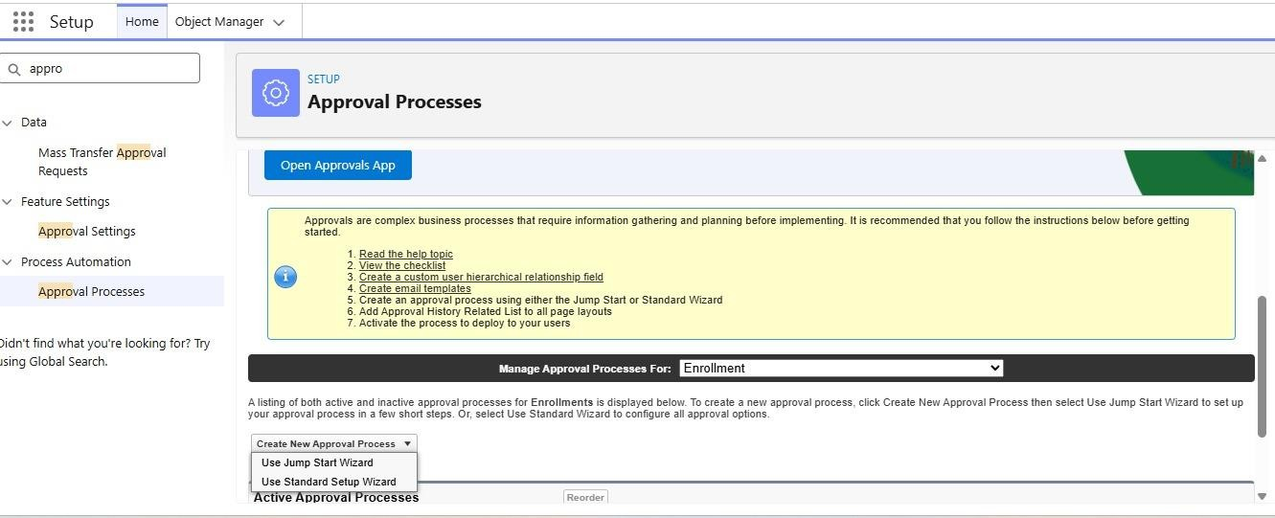

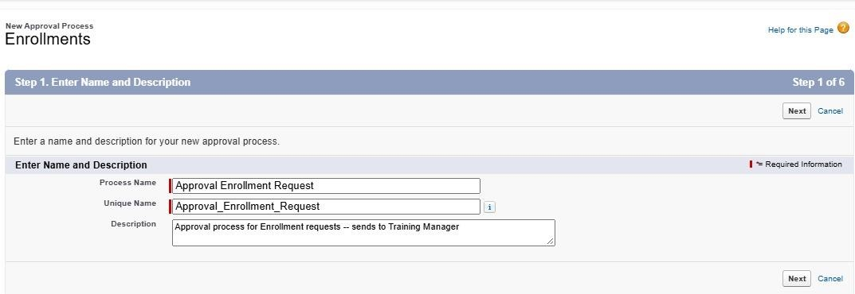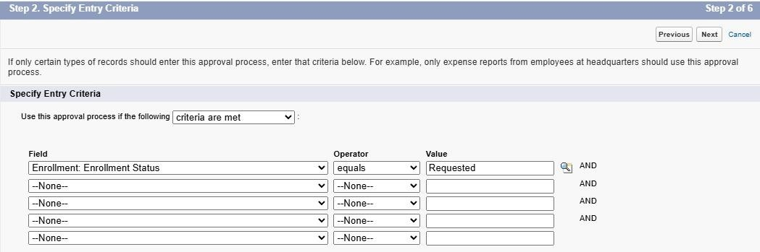

- Approver: specific Training Manager user.
- Under Final Approval Actions:

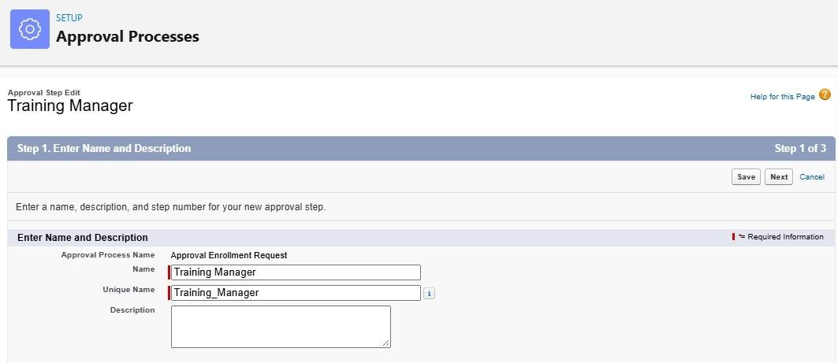
- Add Field Update to set Enrollment_Status__c = "Approved".

- Under Final Rejection Actions:
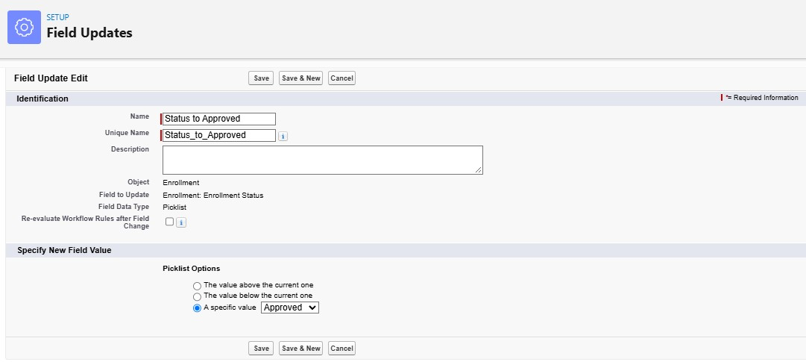
- Add Field Update to set Enrollment_Status__c = "Rejected".

- Add Email Alert to send rejection email to student.

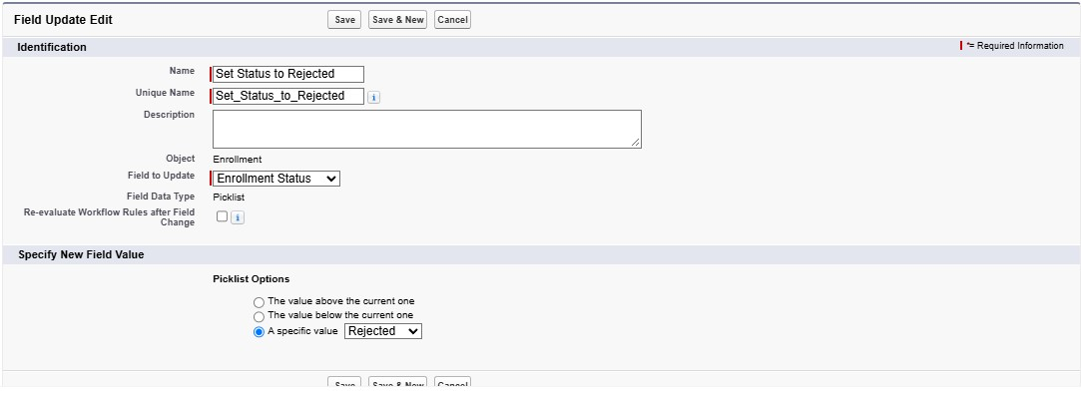

- Activate the approval process.

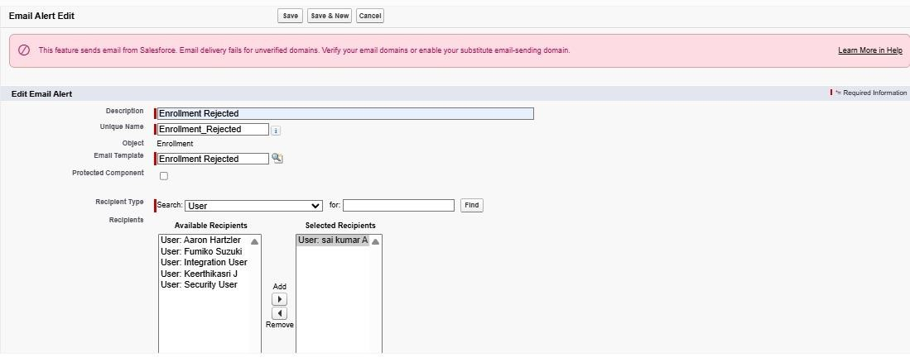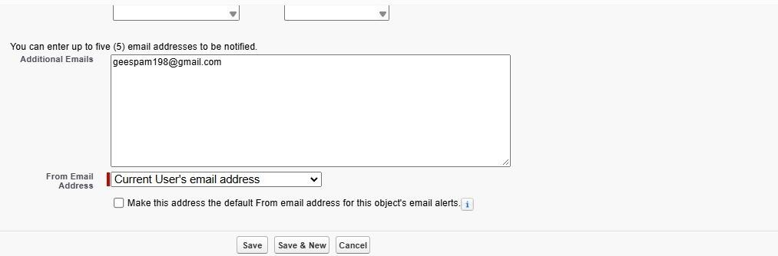

13.
13.Activate the approval process.
Milestone 7- Tabs

Activity 1: Creating a Tab for the Student Object:
Go to Setup.
- In the Quick Find box, type Tabs.
- Under Custom Object Tabs, click New.
- Select Student from the object list.
- Choose a tab style (icon).
- Click Next, assign it to all profiles, and then click Save.

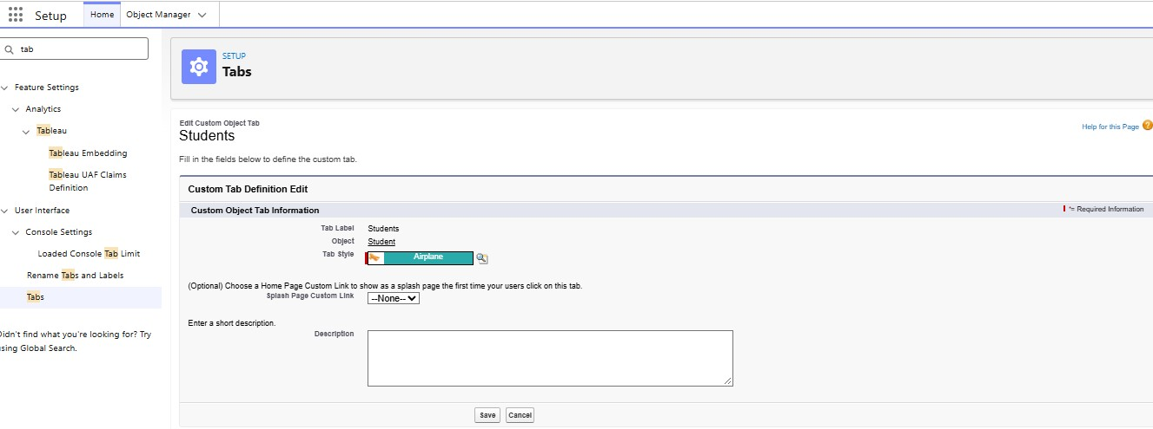

Purpose:

Prevent Enrollment from being approved until fees are paid.

Activity 2: Creating Remaining Tabs
Now create the Tabs for the remaining Objects, they are “Courses, Instructors, Enrollment”.
Follow the same steps as mentioned in Activity -1
Milestone 8 – The Lightning App
Activity 1: Creating the Lightning Application for the Project
Navigate to Setup.
Enter App Manager in the Quick Find search box.
Click New Lightning App.
Provide the app details:
App Name: Student Enrollment & Course Management
Developer Name auto-fills
Description: Optional, but can describe the purpose of the app
Click Next and choose the following settings:
App Branding (optional): Add logo or select color theme
Navigation Style: Choose Standard Navigation
Click Next and assign the app to specific profiles (e.g., Admin, Enrollment
Officer, Instructor).
Click Next to select the items (tabs) to be included in the app. Add:
- Student
- Course
- Instructor
- Enrollment
- Reports
- Dashboards
- Home
- Tasks Click Next and review the app settings.
Finally, click Save & Finish.
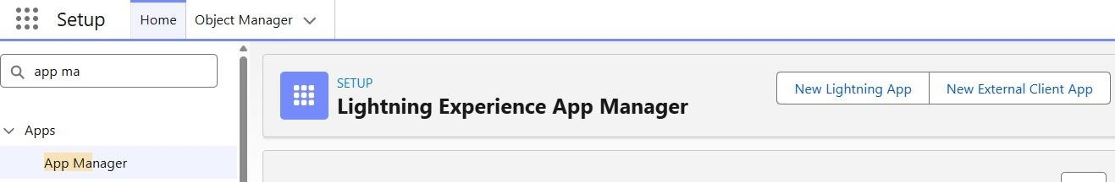

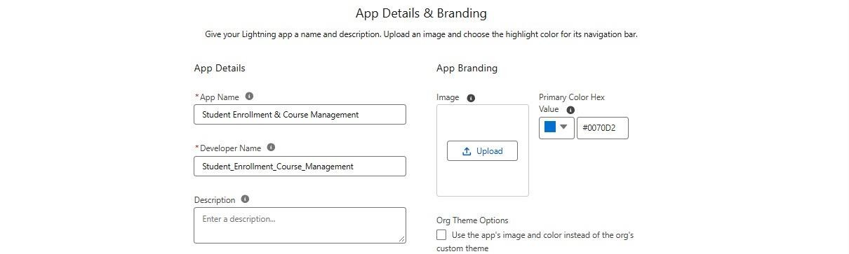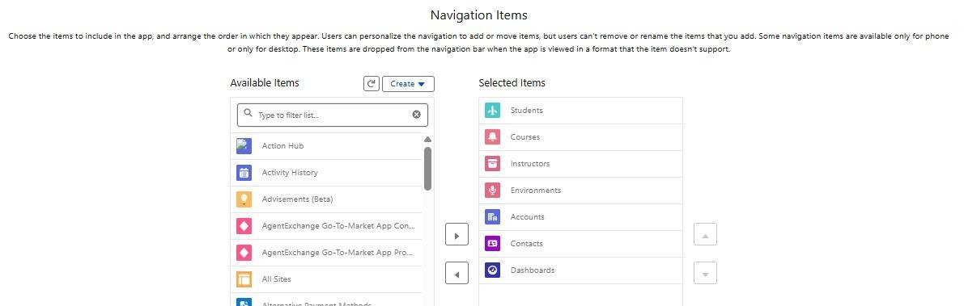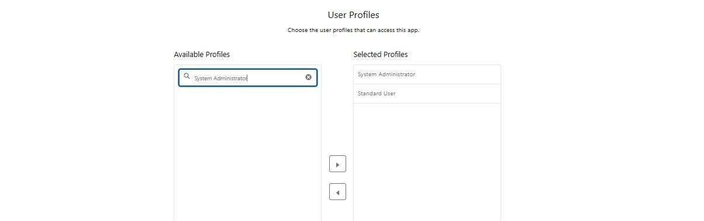

Milestone 9- Page Layouts and Record:
Activity 1: Create Record Types for Enrollment:
Purpose:
To separate New Enrollment vs Re-Enrollment processes.
Steps:
1.Go to Setup → Object Manager → Enrollment__c.
2.Click Record Types → New.
3.For the first record type:
- Existing Record Type: Master
- Record Type Label: New Enrollment
- Enable for required profiles (Admin, Enrollment Officer). ● Select the default Page Layout → Save & New.
4.For the second record type:
- Record Type Label: Re-Enrollment ● Enable for same profiles.
- Select the default Page Layout → Save.

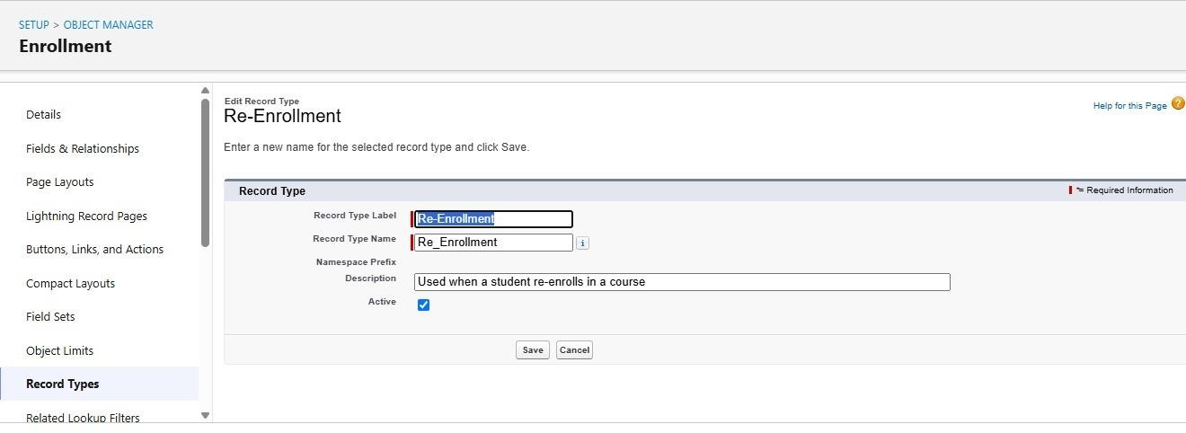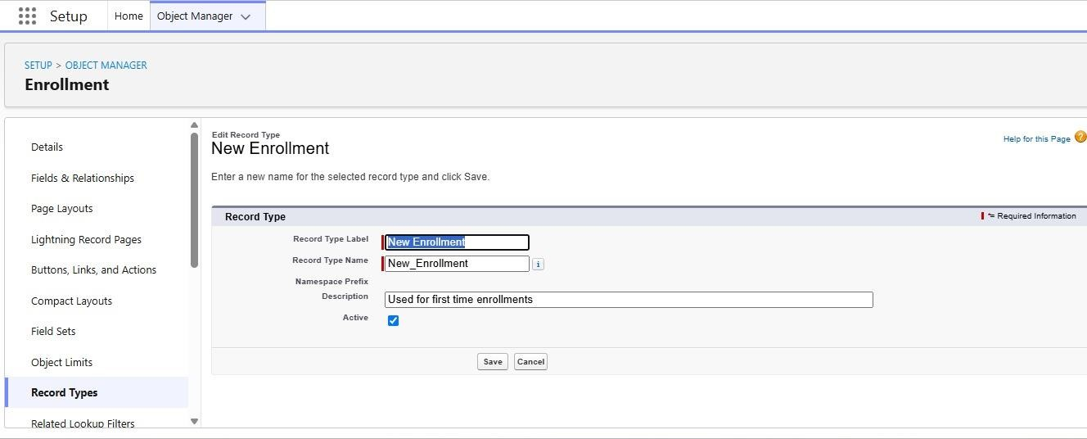

Activity 2: Separate Page Layo Createuts for Each Enrollment Record Type

Purpose:
To show different fields for New Enrollment vs Re-Enrollment.

Steps:

1.Enrollment__c object → click Page Layouts.
2.Click New to create a layout for New Enrollment:
- Clone from existing Enrollment Layout → name it New Enrollment Layout → Save.
- Keep fields relevant for first-time enrollment: Student, Course, Instructor, Enrollment Date, Status, Fees, etc.
- Remove unnecessary re-enrollment fields if any. ● Click Save.

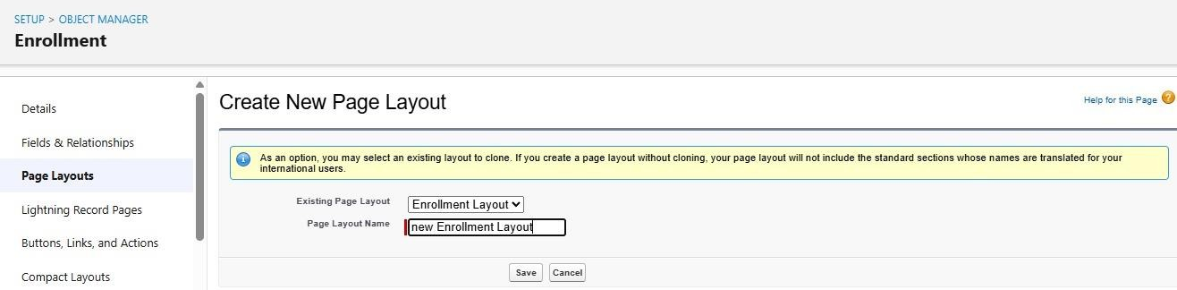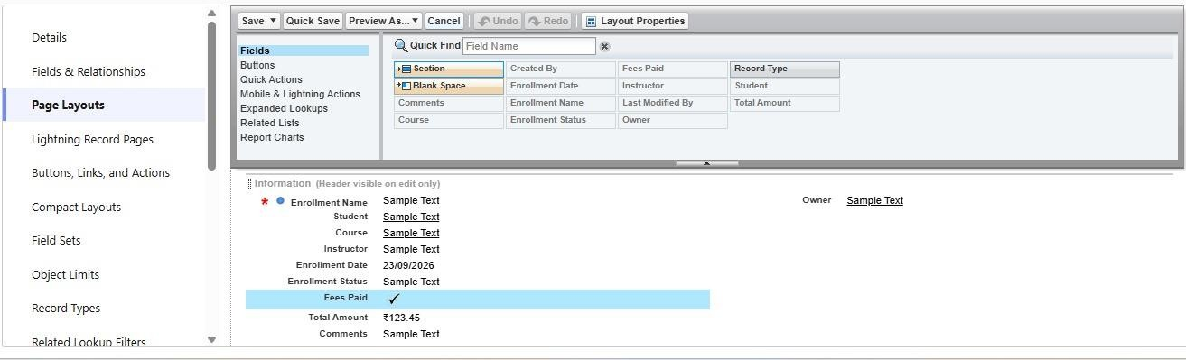

3.Again, click New to create Re-Enrollment Layout:
- Clone existing layout → name it Re-Enrollment Layout → Save.
- Include fields like previous Enrollment reference (if any), Re-Enrollment Reason, Status, Fees, etc. ● Click Save.

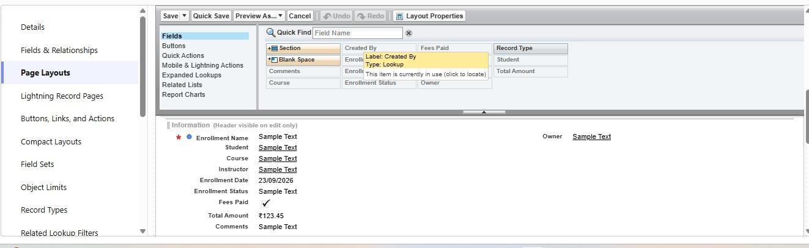

4.Click Page Layout Assignment → Edit Assignment.
5.For each profile and record type:

- New Enrollment → use New Enrollment Layout.
6.Re-Enrollment → use Re-Enrollment Layout.
Click Save.

Activity 3: Enrollment R Addelated Lists to Parent Objects:

Purpose:
To see all Enrollments from Student, Course, and Instructor records. a) Student → Enrollment Related List Go to Setup → Object Manager → Student__c.
Click Page Layouts → open the main layout. In the palette, select Related Lists.
Drag Enrollments related list onto the layout.
Customize columns if needed → Save. b) Course
→ Enrollment Related List
Go to Object Manager → Course__c → Page Layouts.
Open layout → add Enrollments related list.
Save.
c) Instructor → Enrollment Related List
Go to Object Manager → Instructor__c → Page Layouts.
Open layout → add Enrollments related list. Save.

Milestone 10 – Automation with Flow

Activity 1: Auto-Populate Enrollment Date (Record-Triggered Flow)

Purpose:
Set Enrollment_Date__c to today when Enrollment is created.

Steps:

- Go to Setup → Flows → New Flow.
- Select Record-Triggered Flow → Create.
- Object: Enrollment__c.
- Trigger: A record is created.
- Optimize for Actions and Related Records → Done.
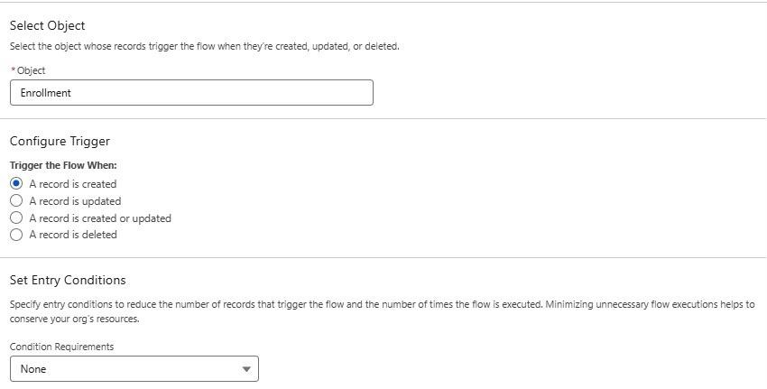

- Add Update Records element: ● Label: Set Enrollment Date.
- Use record that triggered the flow.
- Field: Enrollment_Date__c → Value: $Flow.CurrentDate.
7.Save as SetEnrollmentDate → Activate.
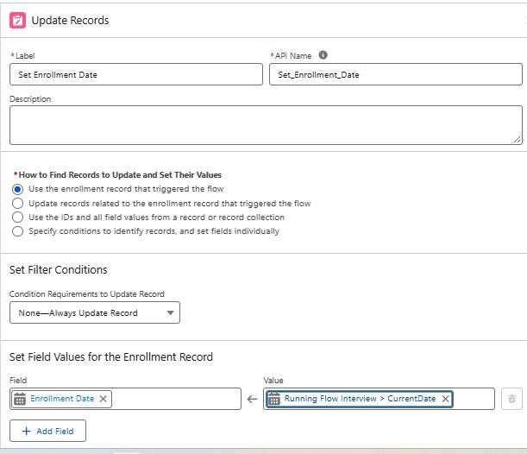

Activity 2: Send Email When Enrollment Approved

Purpose:
When Enrollment_Status__c = Approved, send email, alert admin, and set Student to Active.
Steps (high level for document):

- Create Email Template and Email Alert for student notification.

- Go to Flows → New → Record-Triggered Flow.
- Object: Enrollment__c, Trigger on update.
- Condition: Enrollment_Status__c Equals "Approved".

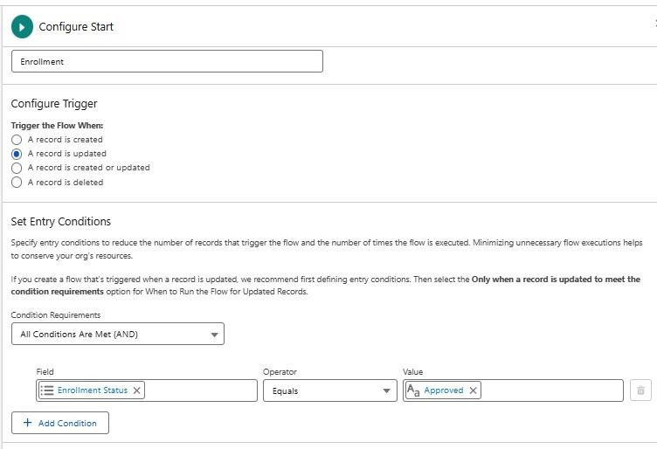

- Add Get Records to fetch related Student__c.

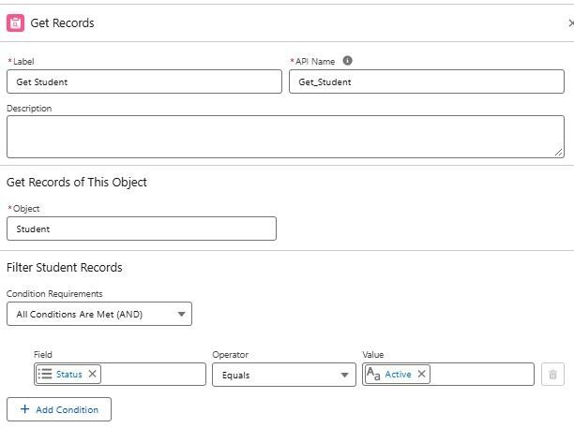

- Add Action (Email Alert) to send email to student.

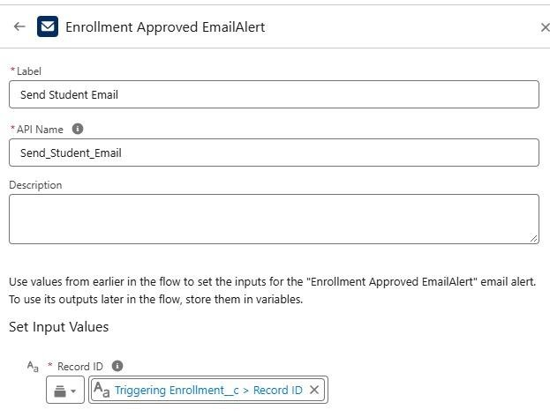

- Add Action to notify Admin if needed.
- Add Update Records to set Student__c.Status__c = "Active".

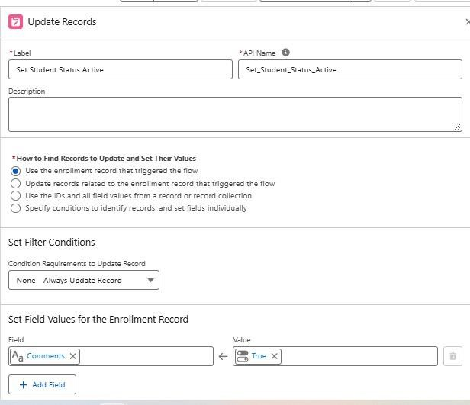

- Save as Enrollment Approved Action → Activate.

Activity 3: Auto-Assign Instructor Based on Course Category

Purpose:
Assign Instructor automatically based on Course category.

Rules:

Technical → Instructor A
Language → Instructor B
Non-Technical → Instructor C

Steps:

- Prepare Instructor__c records with codes (e.g., INSTR_A, INSTR_B, INSTR_C).
- Create Record-Triggered Flow on Enrollment__c (created/updated).
- Add Get Records to fetch related Course__c.
- Add Decision element on Course__r.Category__c:
- Technical / Language / Non-Technical outcomes.
- For each outcome:
- Get Instructor record (A/B/C) based on code or name.
- Update Records: set Instructor__c = Get_Instructor_X.Id.
- Save as AutoAssign_Instructor → Activate.
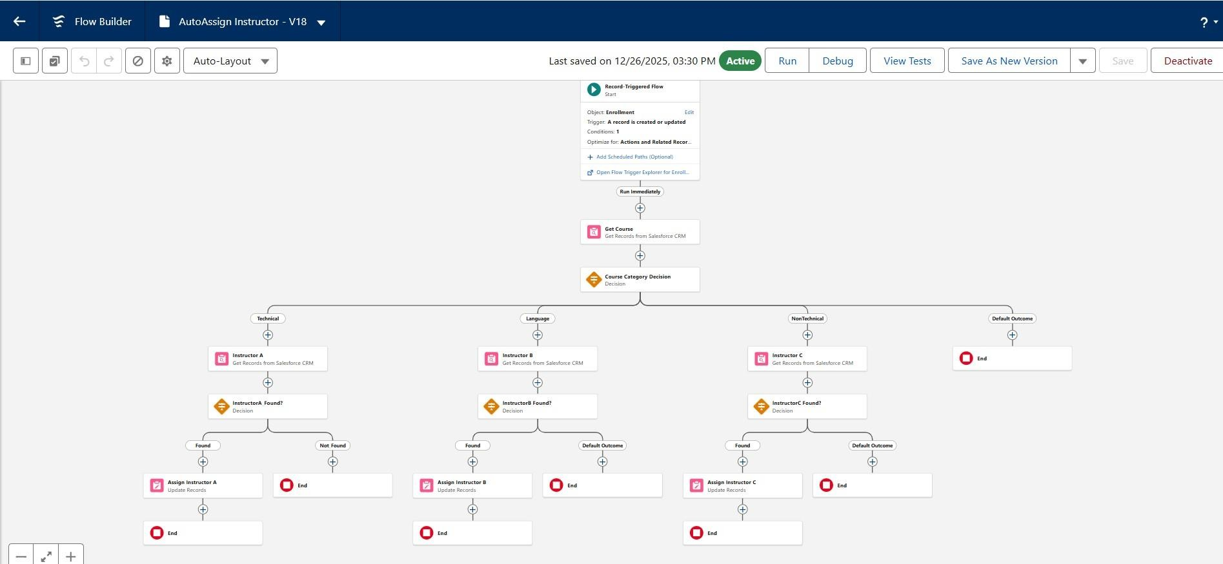

Activity 4: Auto-Create Task for Follow-Up

Purpose:
When Enrollment is “Requested”, create a follow-up task for Admin.

Steps:

- Create Record-Triggered Flow on Enrollment__c.
- Trigger: Record created or updated; condition Enrollment_Status__c = "Requested".

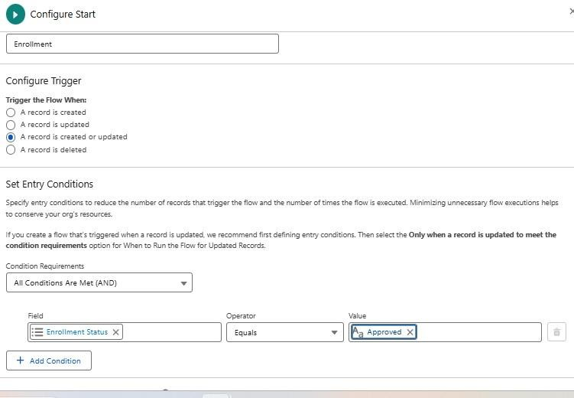

- Add Get Records to fetch Admin user (by Username / Profile).
- Add Formula (Date): TODAY() + 2 for due date.

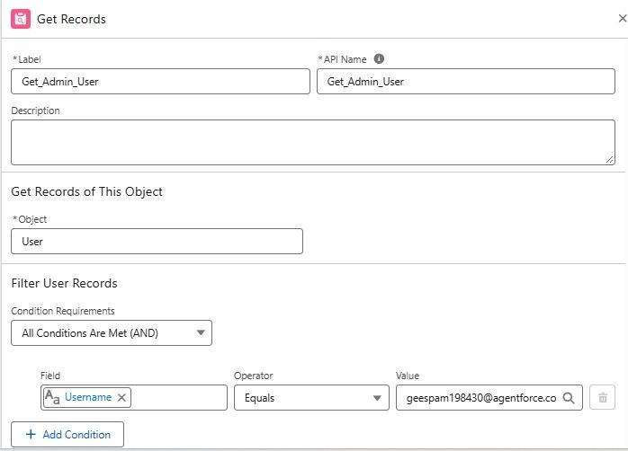

- Add Create Records for Task:
- Subject: Follow up on enrollment request.
- OwnerId: Admin user Id.
- WhatId: Enrollment Id.
- ActivityDate: formula Today + 2.

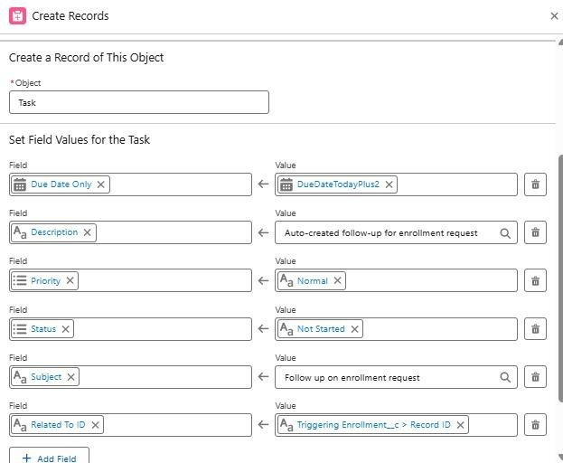

- Save as Create_Followup_Task → Activate.
Milestone 11 – Reports:
Activity 1: Create “Students by Status” Report

1.Go to Reports → New Report.
2.Report Type: Students.
3.Group rows by Status__c.
4.Add columns as needed (Name, Email, Phone).
5.Save as Students by Status.
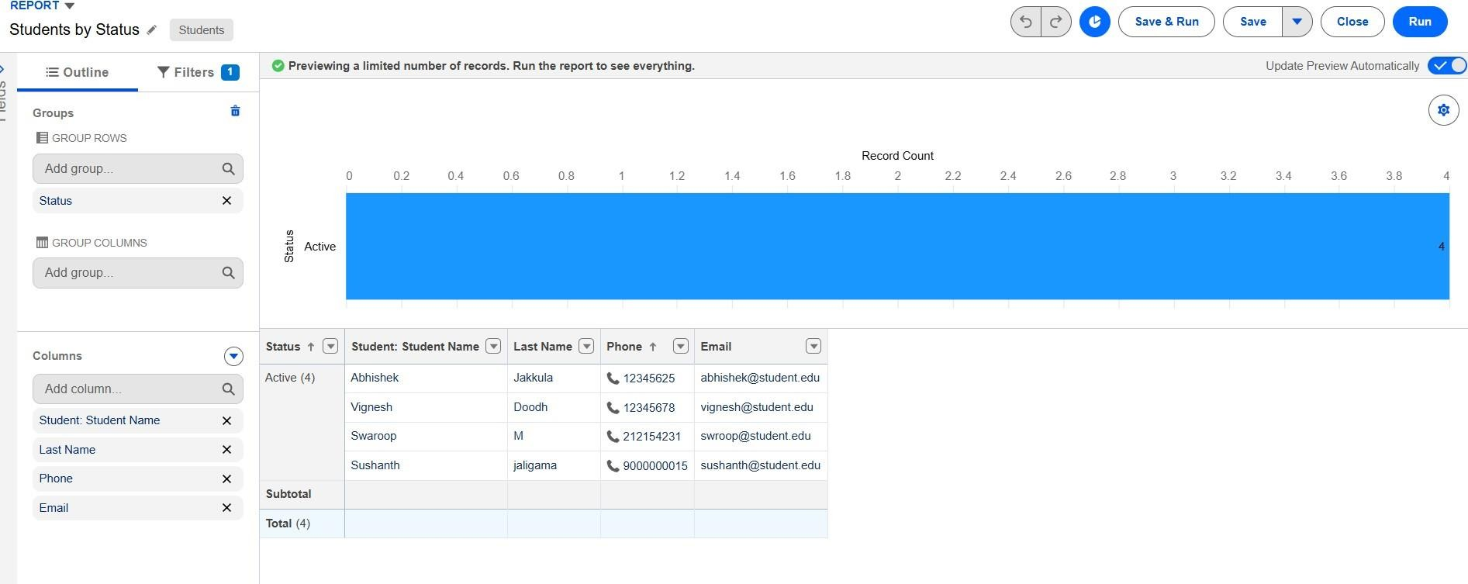

Activity 2: Create “Enrollments by Course” Report

1.New Report → Report Type: Enrollments.
2.Grouprows by Course__r.Name.
3.Show Record Count per course.
4.Save as Enrollments by Course
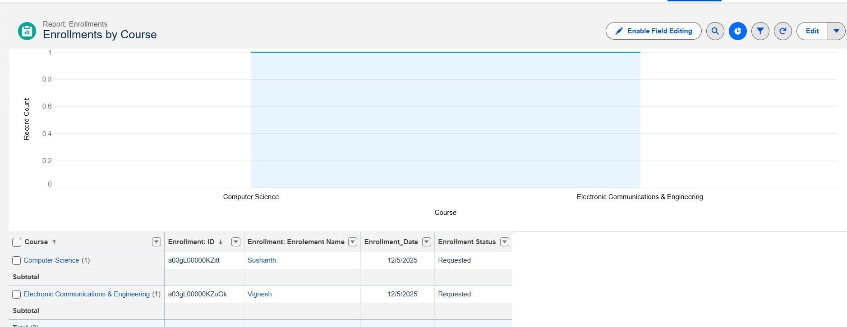
Activity 3: Create “Pending Enrollment Approvals” Report

- New Report → Enrollments report type.
- Filter: Enrollment_Status__c = "Requested".
- Add columns (Student, Course, Owner, Created Date).
- Save as Pending Enrollment Approvals.
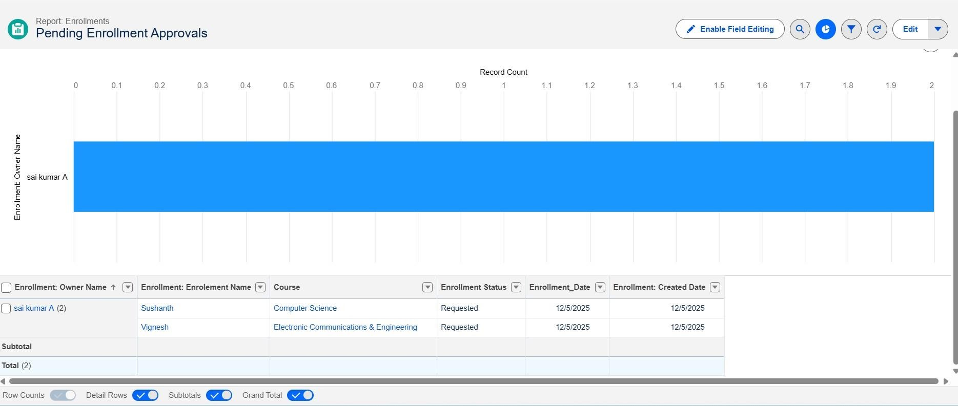
Activity 4: Create “Revenue Report (Fees Paid)” Report

1.New Report → Enrollments report type.
2.Filter: Fees_Paid__c = TRUE.
3.Group by Course__r.Name.
4.Summarize Course_Fee__c or similar fee field.
5.Save as Revenue Report – Fees Paid.
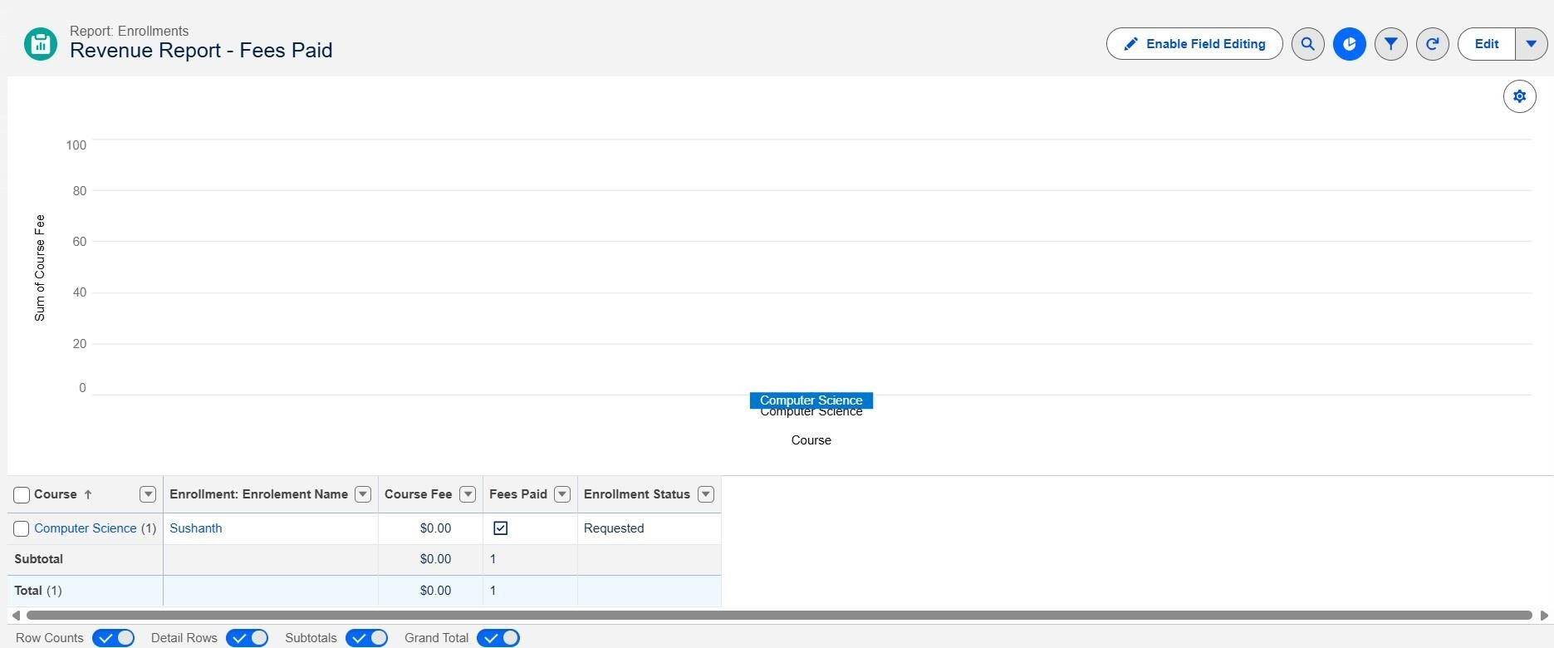
Milestone 12 – Dashboards:

Activity 1: Create “Student Managemet Dnashboard” Steps:
- Go to Dashboards → New Dashboard.
- Name: Student Management Dashboard.
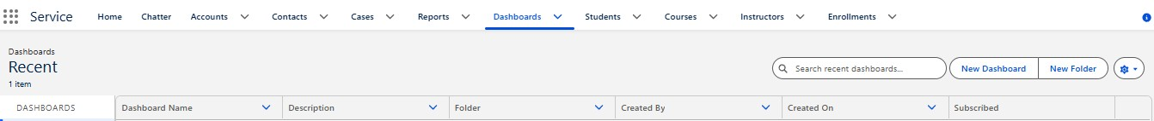
- Select folder → Create.
- Select new Dashboard folder and Save.
Add components:
- Donut Chart → using Students by Status report.
- Bar Chart → using Enrollments by Course report.
- Gauge → using Revenue Report – Fees Paid (sum of revenue field).
- Table → using Pending Enrollment Approvals report.

4. Arrange components on canvas.
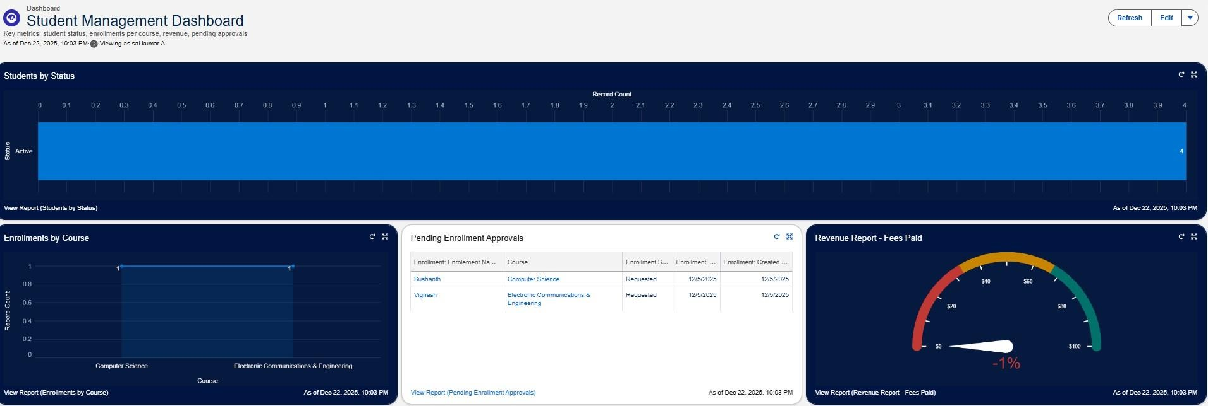
Click Save → Done.

Milestone 13 – Security Setup
Activity 1: Configure Profiles
):
1. Go to Setup → Profiles → New (or CloneProfiles Required:
- Admin – Full access.
- Enrollment Officer – Create/Update Enrollments.
- Instructor – Read-only access to assigned Enrollments.
2. Steps (example for Enrollment Officer fName:
Enrollment Officer. 3. In Object Settings:
○ Enrollment__c: Read, Create, Edit.
○ Student__c / Course__c: Read (and Edit if required).
4. Save.

Repeat similarly for Instructor profile with Read-Only on Enrollments

Activity 2: Create Permission Sets

- Go to Setup → Permission Sets → New.
- Create Custom Object Access (additional access to project objects if needed).
- Create Dashboard Editor (Create/Customize Reports & Dashboards permissions).
- Assign to relevant users.

Activity 3: Configure Sharing & OWD Steps:
- Go to Setup → Sharing Settings.
- Set Organization-Wide Defaults:

○ Students (Student__c): Public Read/Write.
○ Courses (Course__c): Public Read/Write.
○ Enrollments (Enrollment__c): Private. 3. Save.
For Instructor access to assigned Enrollments, optionally:
- Add a User lookup on Enrollment (Instructor User).
- Use a simple Record-Triggered Flow to set OwnerId = Instructor User so they can see only their own records.

7. FUNCTIONAL & PERFORMANCE TESTING

Functional testing checks whether each feature of the Salesforce application works correctly according to the requirements.
In our Student Enrollment & Course Management System, we test:
Student record creation
Course record creation
Instructor record creation
Enrollment creation
Mandatory field validation
Enrollment validation rules
New Enrollment and Re-Enrollment record types
Automated flows
Enrollment approval and rejection
Instructor assignment
Reports
Dashboards
Security and user access Example:
If fees are not paid, the system should not allow an enrollment to be approved. We test whether this validation works correctly.

8. ADVANTAGES & DISADVANTAGES
Advantages
- Centralized Data
All student, course, instructor, and enrollment information is maintained in one Salesforce system.
Example:
Instead of using separate spreadsheets, enrollment officers can access student and enrollment information from Salesforce.
- Automated Workflows
Salesforce Flows and Approval Processes automate repetitive tasks.
Example:
When an enrollment is approved, the system can automatically update the student's status and perform related actions.
- Real-Time Reporting
Reports and dashboards provide current information for decision-making.
Example:
Managers can view enrollment statistics, pending approvals, and revenue information through dashboards.
Disadvantages
- Salesforce Dependency
The application depends on the Salesforce platform to operate.
- Initial Configuration Effort
Setting up objects, fields, relationships, validation rules, flows, approvals, reports, dashboards, and security requires considerable initial configuration
9. Conclusion:
The Student Enrollment & Course Management System (SECMS) successfully provides a centralized Salesforce-based solution for managing the student academic enrollment process. It helps manage student records, courses, enrollments, instructor assignments, approvals, and reporting in an organized manner.
The system reduces manual work by using Salesforce Flows, Validation Rules, and Approval Processes. Reports and dashboards provide real-time information for monitoring enrollment activities and supporting decision-making.
Overall, SECMS improves data accuracy, operational efficiency, workflow management, and transparency. The project demonstrates how Salesforce can be used as a scalable and
user-friendly platform for digitizing the student enrollment process.
Student Enrollment & Course Management System (SECMS)(NM) (1).pdf
Future Scope
The system can be further enhanced with:
Payment gateway integration
Student self-service portal
Advanced analytics and data-driven insights
Mobile access
Additional automation and integrations

11. FUTURE SCOPE
- Payment Gateway Integration
The system can be integrated with an online payment gateway so students can pay enrollment/course fees directly through the system.
- Student Self-Service Portal
A dedicated portal can allow students to:
View their profile
View available courses
Submit enrollment requests
Check enrollment status
View payment information
3. Analytics-Driven Insights
Advanced analytics can be added to analyze enrollment data and provide useful insights for management.
Example: Analyze enrollment trends, course registrations, and student statistics. 4. Mobile Access
The system can be extended to support mobile access, allowing users to access enrollment information and system features through mobile devices.

11. APPENDIX
The Appendix contains additional information and supporting materials related to the Student Enrollment & Course Management System (SECMS). It provides supporting details that help explain the implementation and working of the project.
- Salesforce Objects
The main custom objects used in the project are:
Student – Stores student information.
Course – Stores course details.
Enrollment – Stores enrollment records.
Instructor – Stores instructor information.
- Salesforce Features Used
The project uses the following Salesforce features:
Salesforce Lightning
Custom Objects
Custom Fields
Relationships
Page Layouts
Validation Rules
Salesforce Flows
Approval Process
Reports
Dashboards
Security and Access Control
- Project Workflow
The overall workflow of the system is:
Student Registration → Course Selection → Enrollment Request → Fee Payment → Approval → Instructor Assignment → Reporting & Completion.
Student Enrollment & Course Management System (SECMS)(NM) (1).pdf
- Supporting Screenshots
The appendix can include screenshots of:
  - Salesforce Developer Account
  - Custom Objects
  - Custom Fields
  - Object Relationships
  - Page Layouts
  - Validation Rules
  - Salesforce Flows
  - Approval Process
  - Reports
  - Dashboards
  - Lightning App
  - Security Settings
- Testing Evidence
Screenshots and test results can be included to demonstrate that the major SECMS functions work as expected, including student management, course management, enrollment processing, approval, instructor assignment, reporting, and security.
- Future Enhancements
Possible future enhancements include payment gateway integration, a student self-service portal, advanced analytics, and mobile access.

Thank You

